**How to Build the Dementia Friendly Music Player**

**Standard Model – Use with Headphones or External Powered Speakers**

6 March 2021, <http://DementiaMusicPlayer.org>, Ross Porter [rosswesleyporter@gmail.com](mailto:rosswesleyporter@gmail.com)

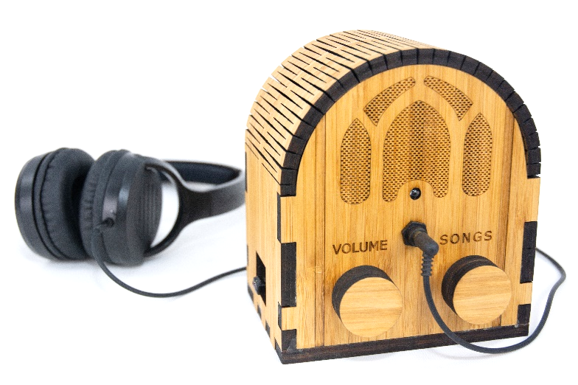  
  
I was inspired to design this by the documentary [Alive Inside](http://www.aliveinside.us/#land) which shows the profound joy felt by some with dementia when listening to their favorite music.

My Dad could no longer operate the home stereo. But he could operate this music player because it operates like a familiar two-knob radio. The vintage style fit with his old intact memories – for most people with dementia, the old memories are the strong memories.

It’s easier than you think to make one. Everything I did is open source. This document contains all the information you need. You can order the parts online, including the cut & engraved wood. It’s a good family project – kids do well with this. It’s also a project that friends would love to help you with.



|  |  |
| --- | --- |
| **Parts cost** | ~$135 + tax + shipping  (~$70 if you make 10+ at a time, see Appendix 1) |
| **Music cost** | Minimal as you should use the recipient’s existing music collection |
| **Build time** | About 3 hours once you have the parts & music,  Best if those 3 hours are spread across two days |
| **Parts source** | All parts can be mail ordered, links below |
| **Soldering?** | No |
| **Woodworking?** | No |
| **Laser cutter needed?** | No, you can mail order the pre-cut pieces for the wood case |
| **With a friend?** | Good idea, especially if your friend has the basic tools required |
| **Beverage?** | I recommend a hoppy IPA while you are assembling |

# No warranty

USE THESE DEMENTIA FRIENDLY MUSIC PLAYER PLANS AND SYSTEM AT YOUR OWN RISK. THE DEMENTIA FRIENDLY MUSIC PLAYER PLANS ARE PROVIDED AS IS WITHOUT WARRANTY OF ANY KIND EITHER EXPRESSED OR IMPLIED, INCLUDING, BUT NOT LIMITED TO, THE IMPLIED WARRANTIES OF MERCHANTABILITY AND FITNESS FOR A PARTICULAR PURPOSE. THE ENTIRE RISK AS TO THE QUALITY AND PERFORMANCE OF THE PLANS AND SYSTEM IS WITH YOU. SHOULD THE PLANS OR SYSTEM PROVE DEFECTIVE, YOU ASSUME THE COST OF ALL NECESSARY SERVICING, REPAIR OR CORRECTION. IN NO EVENT WILL ANY PARTY BE LIABLE TO YOU FOR DAMAGES, INCLUDING ANY GENERAL, SPECIAL, INCIDENTAL OR CONSEQUENTIAL DAMAGES ARISING OUT OF THE USE OR INABILITY TO USE THE PLANS OR SYSTEM.

# Acknowledgements

People were very generous with their time, and I really enjoyed the experience. This is certainly an incomplete list: Alex & Mike & others at [Ada’s](http://blog.seattletechnicalbooks.com/), the super smart staff at [Metrix](http://www.metrixcreatespace.com/), neighbor Randy, [Stephen Christopher Phillips](http://scphillips.com/), [Bob Rathbone](http://www.bobrathbone.com/), [Stephen Rusk](http://www.stephenrusk.com/), [Graham Hill](http://www.ted.com/speakers/graham_hill), support at [Ponoko](https://www.ponoko.com/), [Florian Festi](https://www.festi.info/boxes.py/index.html), and my son.

# How it works

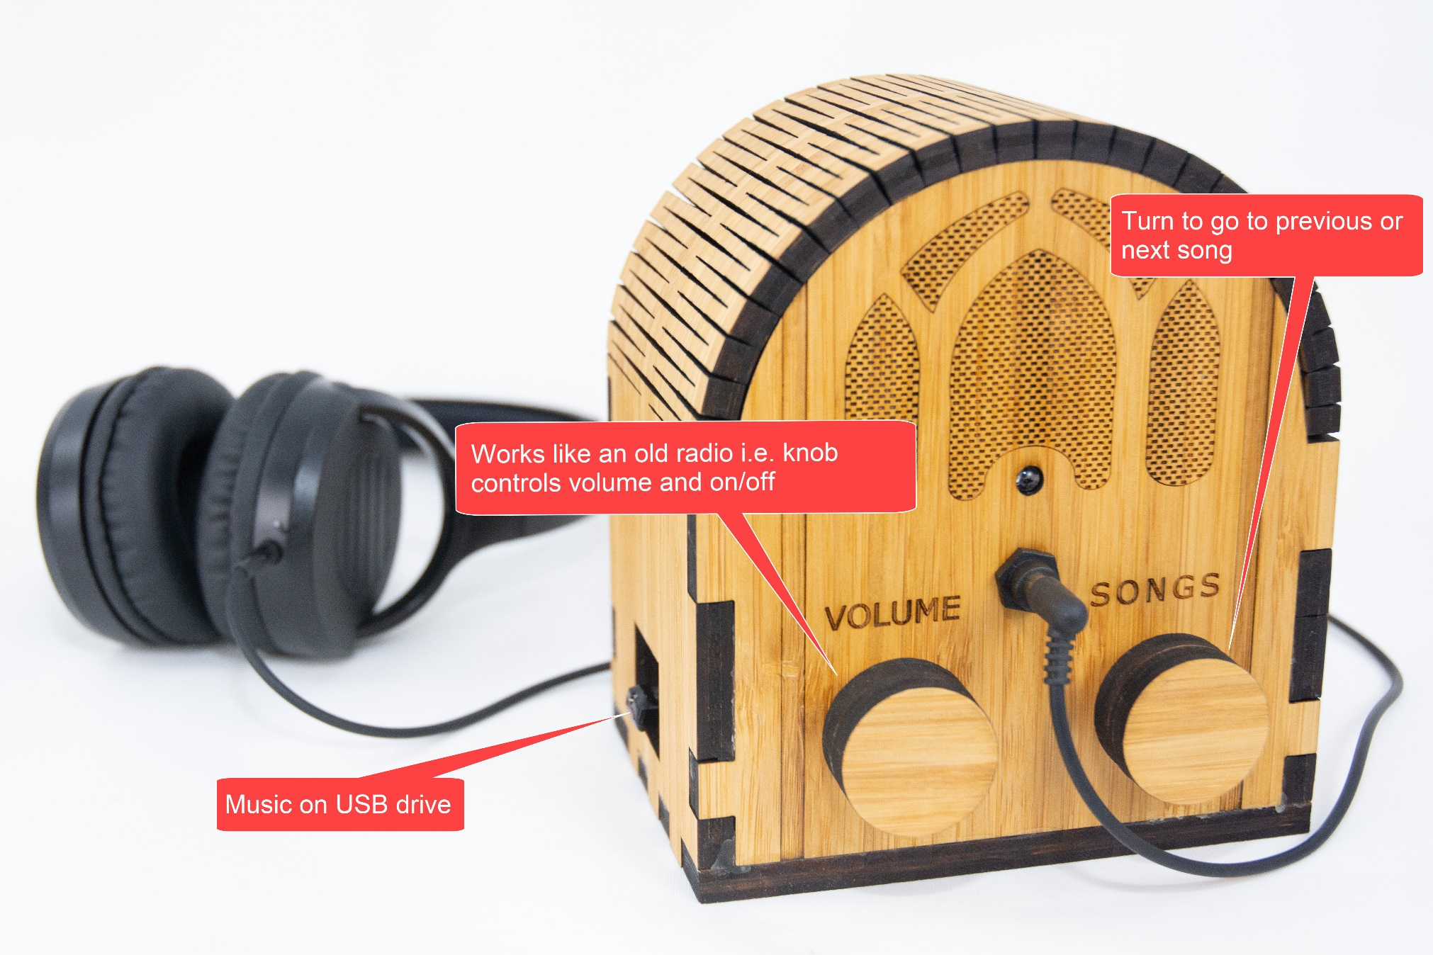

# Preview of the steps

|  |  |  |
| --- | --- | --- |
| **STEP 1: Order or make the case** | **STEP 2: Order parts** | **STEP 2: Assemble music**  Complete Beethoven Edition, Vol. 1: Symphonies |
| **STEP 4: Flash the micro SD card**  http://ecx.images-amazon.com/images/I/71sgCaQGpKL._SL1500_.jpg | **STEP 5: Add the Pi** | **STEP 6: Wire it** |
| **STEP 7: Test it** | **STEP 8: Glue it** | **STEP 9: Enjoy!** |

# STEP 1: Find a friend to do this with

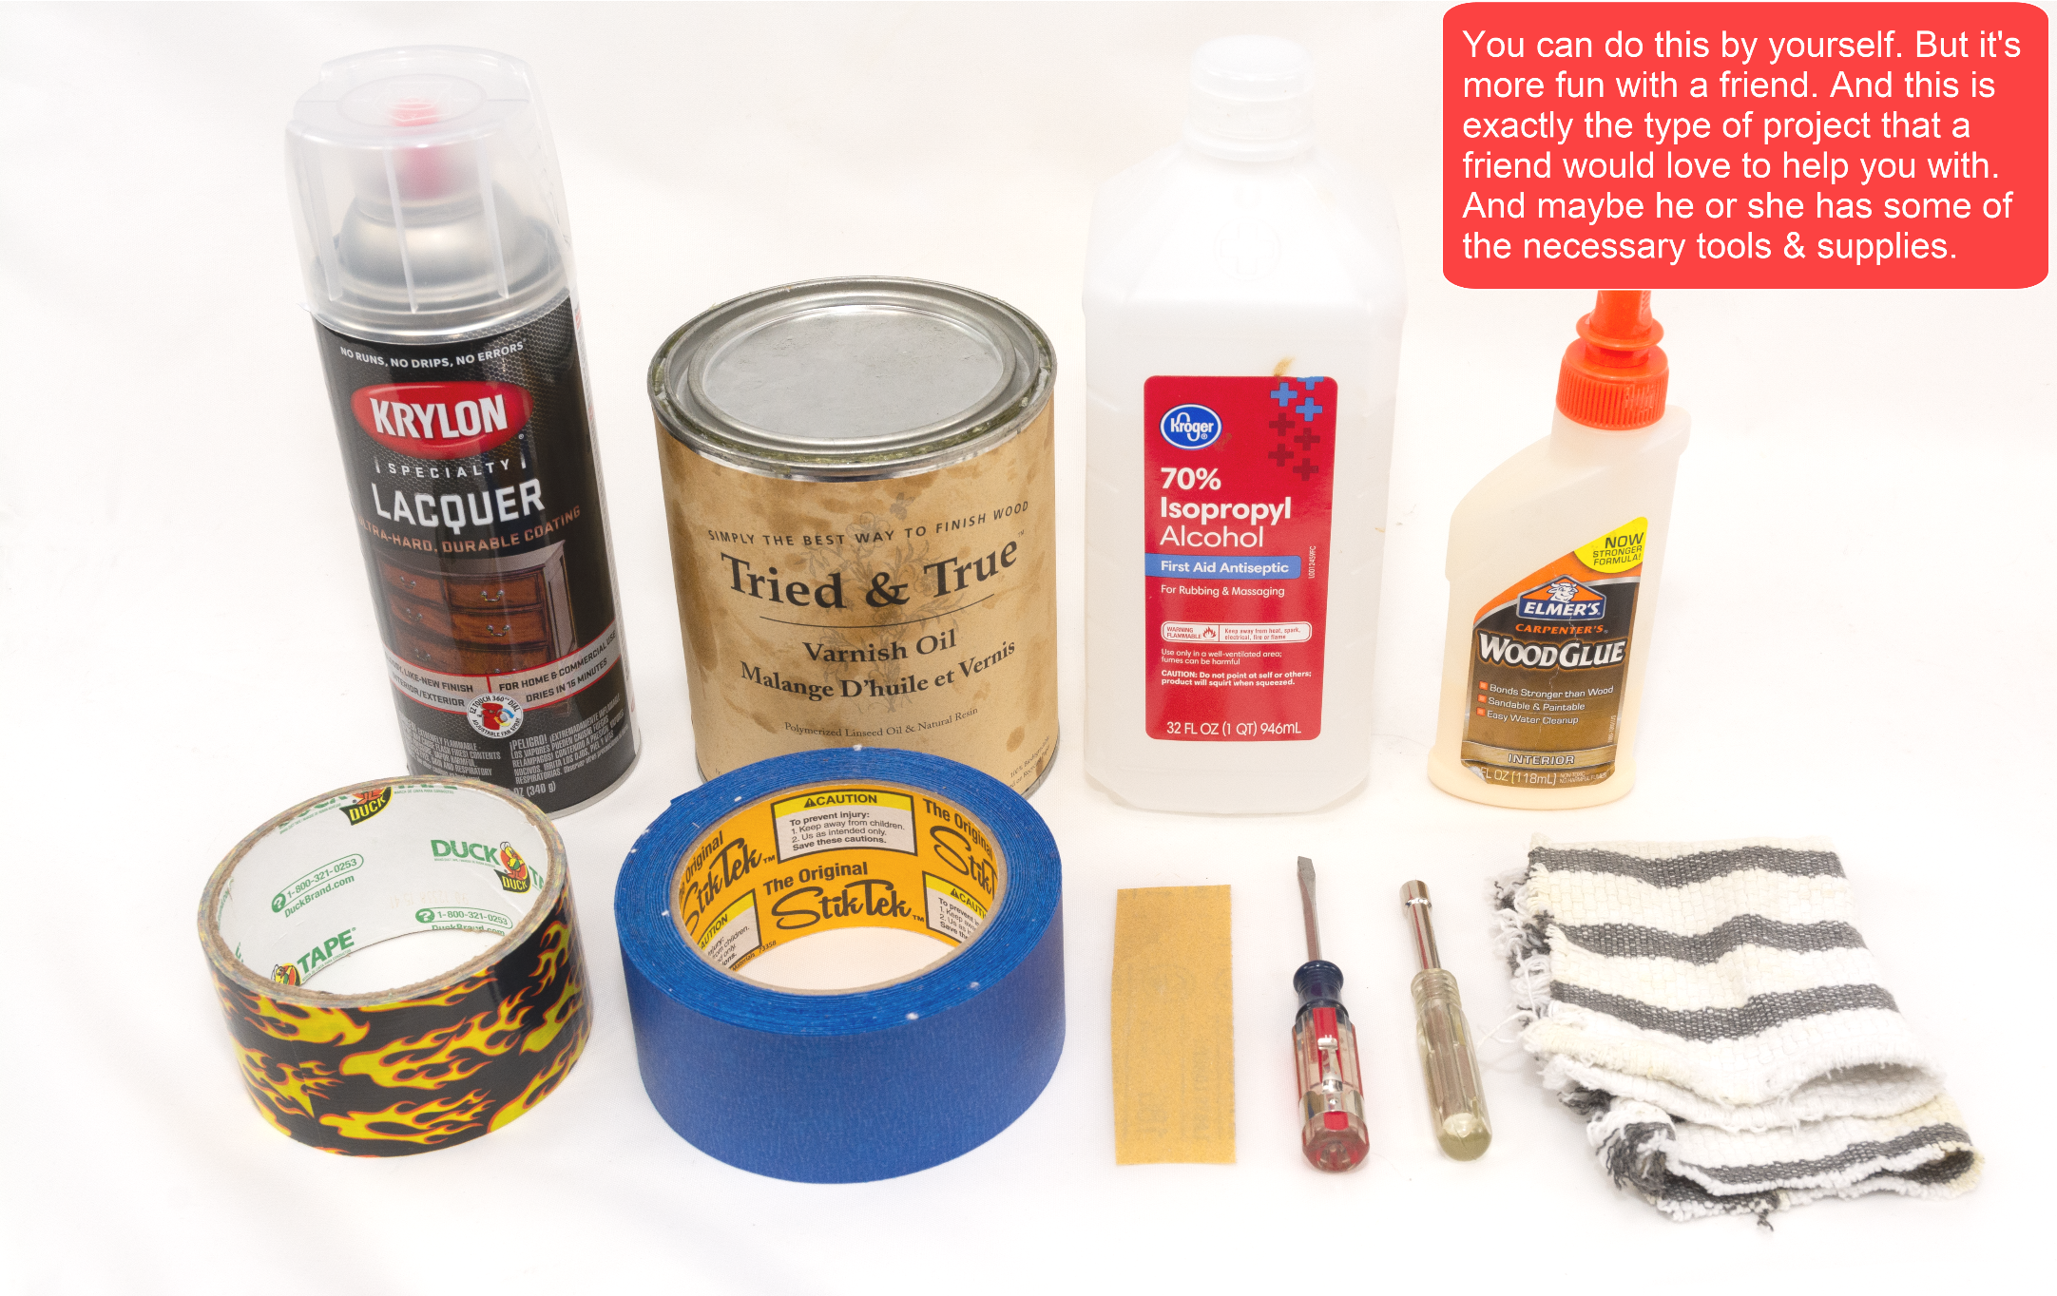

# STEP 2: Decide about making vs. ordering the case

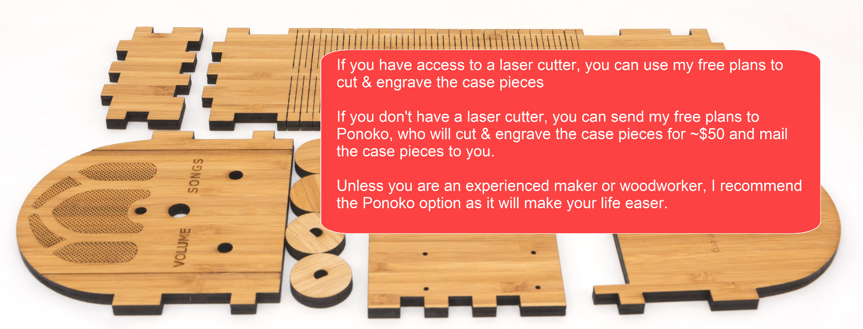

Ponoko is a company that laser cuts wood and sends you the precisely cut pieces. You don’t need to use Ponoko – you are welcome to download my case design files from [github](https://github.com/rosswesleyporter/dqmusicbox/tree/master/case/standard_model) and go to your local maker space and use the laser cutter there. Or buy yourself a laser cutter (if you do, will you be my friend?). In other words, Ponoko is convenient but not necessary. I have no affiliation with them, other than being a happy customer. Unless you are an experienced maker or woodworker, I recommend ordering the case – it will make the build process much easier.

# STEP 3: Get the case file

1. Go to <https://drive.google.com/drive/u/0/folders/1OfONeFgfn9vb6FGjCZ25AI0l-HxRqxYo>

2. Get the file you want:



3. Right-click on the desired file, choose “Download”

# STEP 4: Order the case

1. Go to <https://www.ponoko.com/>
2. Login (create an account if you haven’t already)
3. Choose “Upload your design” and upload the file that you downloaded just above  
   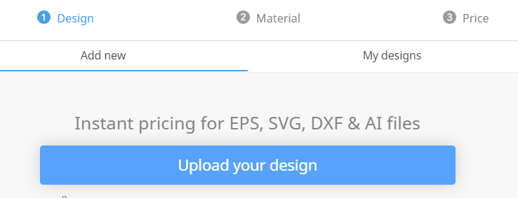
4. Set the design colors as per below:  
   
5. Choose “Confirm design size & colors”
6. Choose “Amber Bamboo Plywood”  
   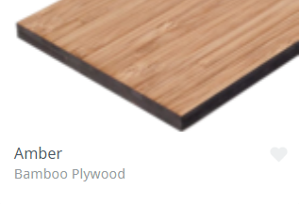
7. Choose thickness = 6.7mm and then “Confirm material”  
   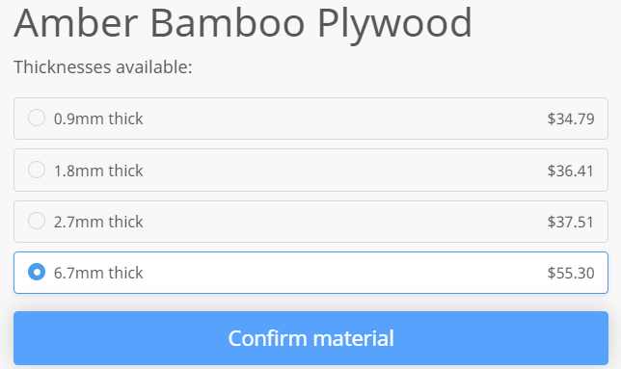
8. Make sure that everything looks as expected especially the check that the horizontal bar above SONGS is colored in  
   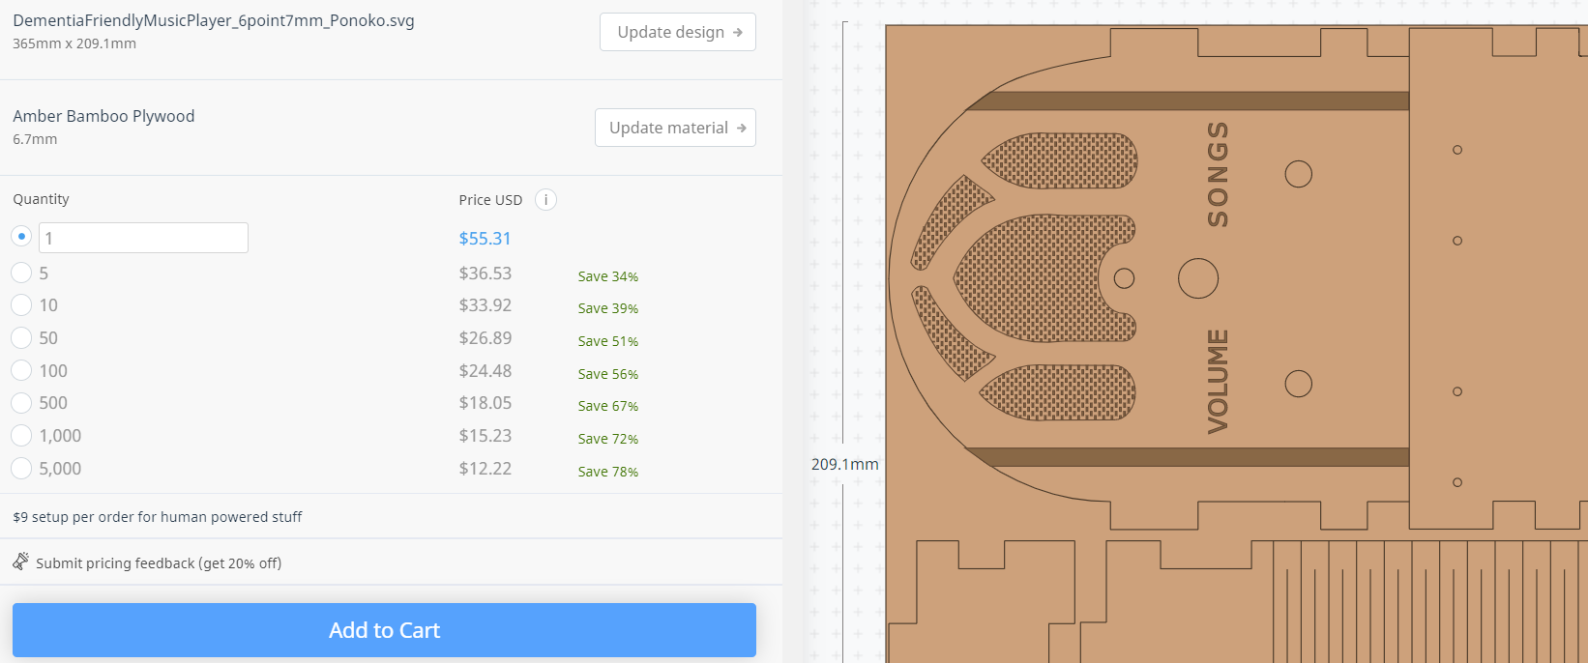
9. Click “Add to Cart”

# STEP 5: Make the case (if you didn’t order it)

If you want to make the case rather than order the case:

1. Use the file that you downloaded earlier
2. If you like, you can customize the case
3. Cut on your laser cutter or go to a makerspace and use a laser cutter there

If you are curious, this is what a design file looks like (showing the .lbrn Lightburn file):

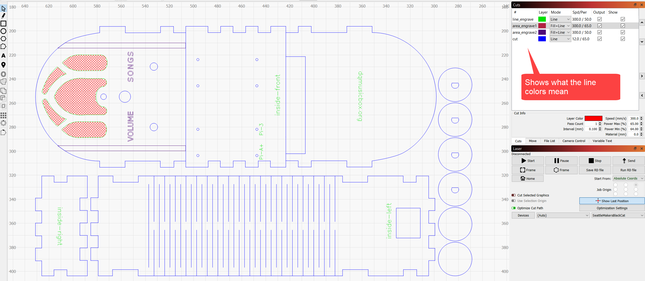

# STEP 6: Order the parts

If you plan to make 10+ units, see Appendix 1, rather than the table below.

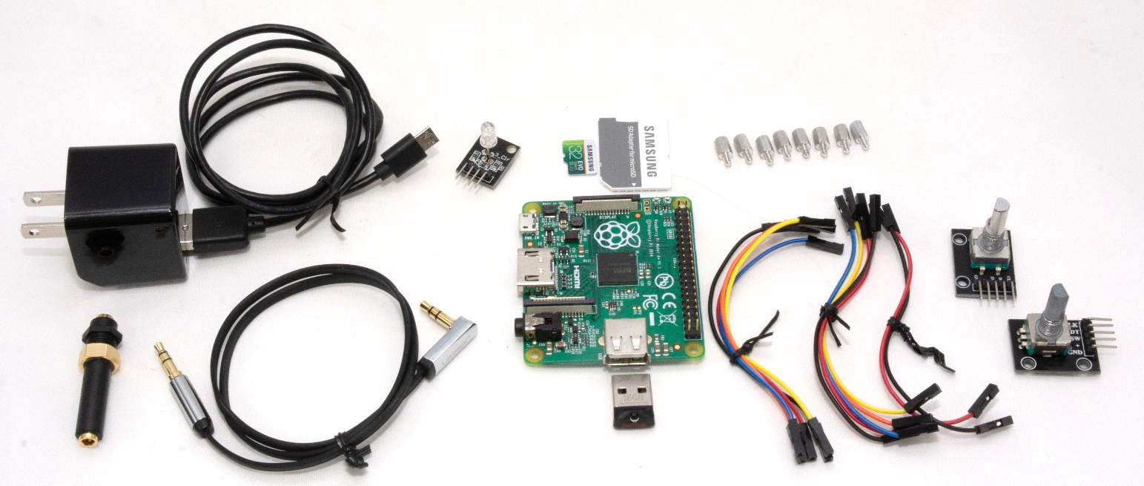

|  |  |  |  |
| --- | --- | --- | --- |
| **Item** | **Supplier** | **Cost** | **Notes & alternatives** |
| Bamboo case | Ponoko | $64.68 | See instructions above. |
| [Raspberry Pi 1 A+ single board computer](http://www.newark.com/raspberry-pi/raspbrry-moda-512m/silicon-manufacturer-broadcom/dp/81Y5333) | Newark | $20.00 | Also tested with a 2B, 3A+, 3B, 3B+, 4B. Do not use Pi Zero. |
| [Power supply](https://www.newark.com/pro-elec/28-19339/adaptor-ac-dc-5-1v-2-5a/dp/51AC7144) | Newark | $4.99 | Or Newark 81AC2845. Or order one for your region/plug. |
| [Female-female jumper wires](http://www.newark.com/adafruit/266/female-to-female-jumper-wires/dp/42X1200) | Newark | $3.95 | Or Amazon B01L5ULRUA |
| [Panel mount 3.5mm headphone jack](http://www.newark.com/mcm/27-5937/3-5mm-inline-stereo-mount-female/dp/40T6284) | Newark | $2.69 | Or Amazon B004JX64FE |
| [M2.5 standoffs (screws) – 8 of them](https://www.newark.com/raf-electronic-hardware/m2102-2545-al/spacer-standoff-hex-aluminium/dp/27T7975?st=M2.5%20standoff) | Newark | $7.12 | Or Amazon B06XXV8RTR |
| [16GB or greater micro SD card](https://www.amazon.com/gp/product/B06XWN9Q99/ref=ppx_yo_dt_b_asin_title_o05_s00?ie=UTF8&psc=1) | Amazon | $7.49 | Or buy Amazon B06XWN9Q99 or other 16GB+ card |
| [USB thumb drive](https://www.amazon.com/gp/product/B077Y149DL/ref=ppx_yo_dt_b_search_asin_title?ie=UTF8&psc=1) | Amazon | $7.19 | Or Amazon B07MDXBT87 or other physically small USB drive |
| [Audio cable](https://www.amazon.com/gp/product/B00LM0U8I6/ref=oh_aui_detailpage_o00_s00?ie=UTF8&psc=1) | Amazon | $6.59 | Or buy Amazon B00SUIKMJ8 or other cable with right angle bend |
| [KY-016 indicator LED](https://www.banggood.com/5Pcs-KY-016-RGB-3-Color-LED-Module-Red-Green-Blue-p-954086.html?rmmds=search&cur_warehouse=CN) | Banggood | $4.61 | ALLOW 3+ WEEKS TO ARRIVE FROM CHINA. Due to COVID, it's hard to find these in the US. You can get it quickly from Amazon B07KJYR8K1, but costs $18. |
| [KY-040 rotary encoders (knobs)](https://www.amazon.com/Tegg-KY-040-Encoder-clickable-Arduino/dp/B07QL6V4WP/ref=sr_1_11?keywords=KY-040&qid=1572122001&sr=8-11) | Amazon | $7.99 | Or buy Amazon B06XQTHDRR |
|  |  | **$137.30** | Prices will vary. Does not include tax, shipping. |

# STEP 7: Decide between headphones and speakers



The device is designed to be used with either headphones or external powered speakers. But not both at the same time. It does not automatically switch between headphones and speakers. You can make the change, but you must actually unplug one device from the headphone jack and plug in another. Thus, for the sake of the users, I suggest choosing one device and sticking with it.

For the purposes of these instructions, I’ll assume that you chose to use headphones.

# STEP 8: Get headphones (optional)

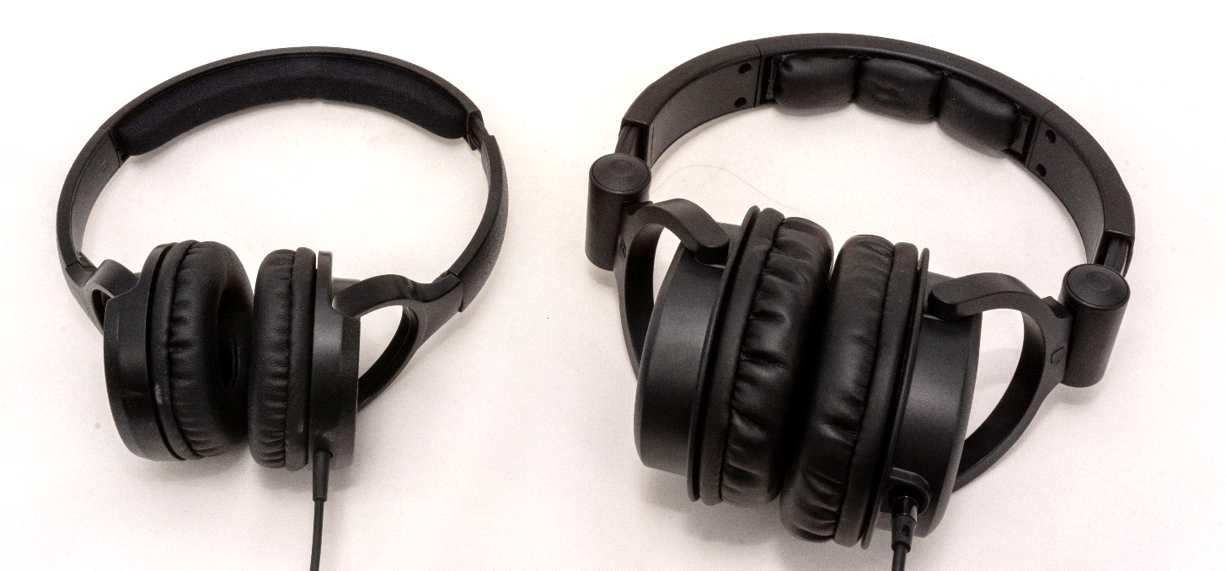

## Some headphone choices

|  |  |  |
| --- | --- | --- |
| **Item** | **Cost** | **Notes and alternatives** |
| The recipient’s existing headphone | $0.00 | The best headphones are the headphones that the recipient is already used to. |
| [Monoprice On-Ear headphones](https://www.monoprice.com/product?c_id=120&cp_id=12001&cs_id=1082302&p_id=13191&seq=1&format=2) | $10.99 | Very good sound. High sensitivity (which is important). Also available from Amazon for a slightly higher price but with Prime shipping: [B014399CWK](https://www.amazon.com/Monoprice-Lightweight-Headphones-Controls-Microphone/dp/B014399CWK/ref=sr_1_2?keywords=monoprice+on-ear&qid=1577058123&sr=8-2). |
| [Monoprice Over-the-Ear headphones](https://www.monoprice.com/product?c_id=120&cp_id=12001&cs_id=1082302&p_id=8323&seq=1&format=2) | $15.99 | Amazing sound. High sensitivity (which is important). Also available from Amazon for a slightly higher price but with Prime shipping: [B007SP2CO2](https://www.amazon.com/Monoprice-Headphones-Single-Button-Microphone-Controller/dp/B007SP2CO2/ref=sr_1_3?crid=3P248UWO7A44N&keywords=monoprice+over+ear+headphones&qid=1577058242&sprefix=Monoprice+over+ear%2Caps%2C209&sr=8-3). |
| Other |  | Look for high sensitivity headphones, as the Pi’s output is a bit weak. |

# STEP 9: Get speakers (optional)



## Some speaker choices

|  |  |  |
| --- | --- | --- |
| **Item** | **Cost** | **Notes and alternatives** |
| [ARVICKA Computer Speakers](https://www.amazon.com/gp/product/B01KC7WGQQ/ref=ppx_yo_dt_b_search_asin_title?ie=UTF8&th=1) | $19.99 | Surprisingly good sound for the tiny size. I quite like them. Simple – no visible controls on the front. USB powered, so if you choose a Pi 3 or Pi 4 (above), you can power these speakers from the device. Otherwise, you’ll also need a USB charger e.g. Amazon B0773J79KC. |
| [Creative Pebble](https://www.amazon.com/Creative-Labs-Pebble-Black-Loudspeaker/dp/B0791H74NT/ref=sr_1_4?dchild=1&keywords=computer+speakers&qid=1584929741&sr=8-4&swrs=EDF10094F276CBAC54A0E02B25FE9080) | $19.99 | I have not tried this. Highly rated on Amazon. USB powered (see note in the row above). |
| [Other – Amazon search](https://www.amazon.com/s?i=aps&k=computer%20speakers&ref=nb_sb_noss_2&url=search-alias%3Daps) |  | Lots of other speakers to choose from. |

# STEP 10: Get wood finish product (optional)

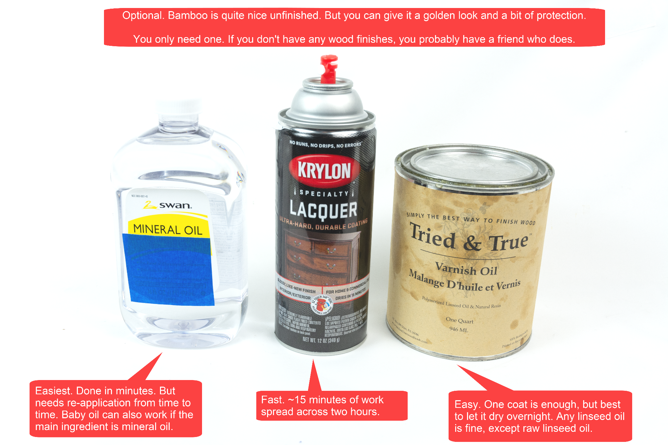

# STEP 11: Gather tools & supplies

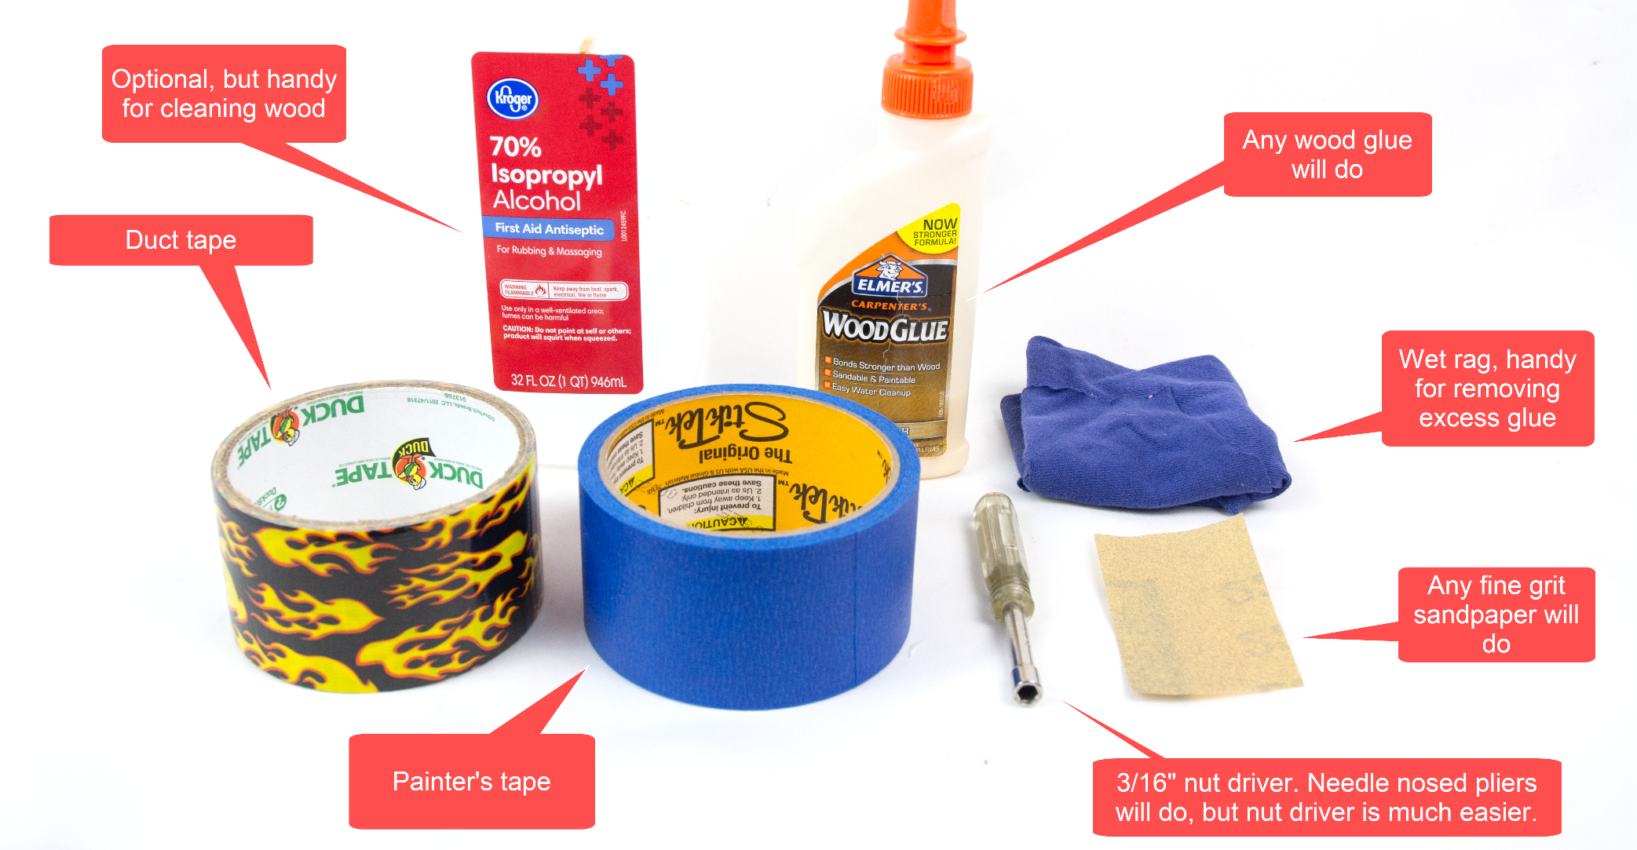

# STEP 12: Get a computer with an SD card slot

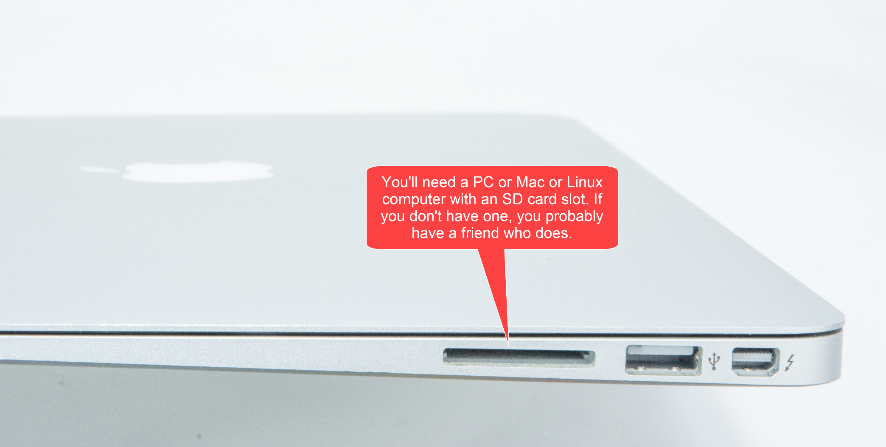

# STEP 13: Assemble the personalized collection of music

## Choosing the music – go for familiar favorites

This is the most important step. The personalized (familiar) music is the fundamental magic. You don’t need much music, perhaps 6-10 albums. But only familiar favorites. In my case, my Mom mailed me my Dad’s favorite CDs. It will take two weeks for the parts above to arrive, so you have time to do this well. Though it is easy to change the set of music later.

## Put the music on the USB memory stick

Organize the digitized music into folders on the USB memory stick, one folder per album. MP3, iTunes, and FLAC files are supported i.e. files with extensions .mp3, .m4a, .flac. In the end, you should have a set of folders that looks something like this:



# STEP 14: Copy software to the micro-SD memory card

I prepared a disk image for you. It has all the required software. Your job is to download this disk image and then write it to the micro-SD card. The steps:

1. Install [Balena Etcher](https://www.balena.io/etcher/) on your PC or Mac or Linux computer. [Win32 Disk Imager](http://sourceforge.net/projects/win32diskimager/) also works.
2. Download the [Dementia Friendly Music Player disk image](http://bit.ly/2JYW5ED).
3. Confirm download – “Download anyway”  
   
4. Put the micro-SD memory card & adapter into the SD reader/writer in your computer.
5. Start Balena Etcher, instruct it to write the image file to the SD card:  
   
6. Wait for the writing to complete, ~10 minutes. This would be a good time to make a sandwich.

# STEP 15: Apply a wood finish (optional)

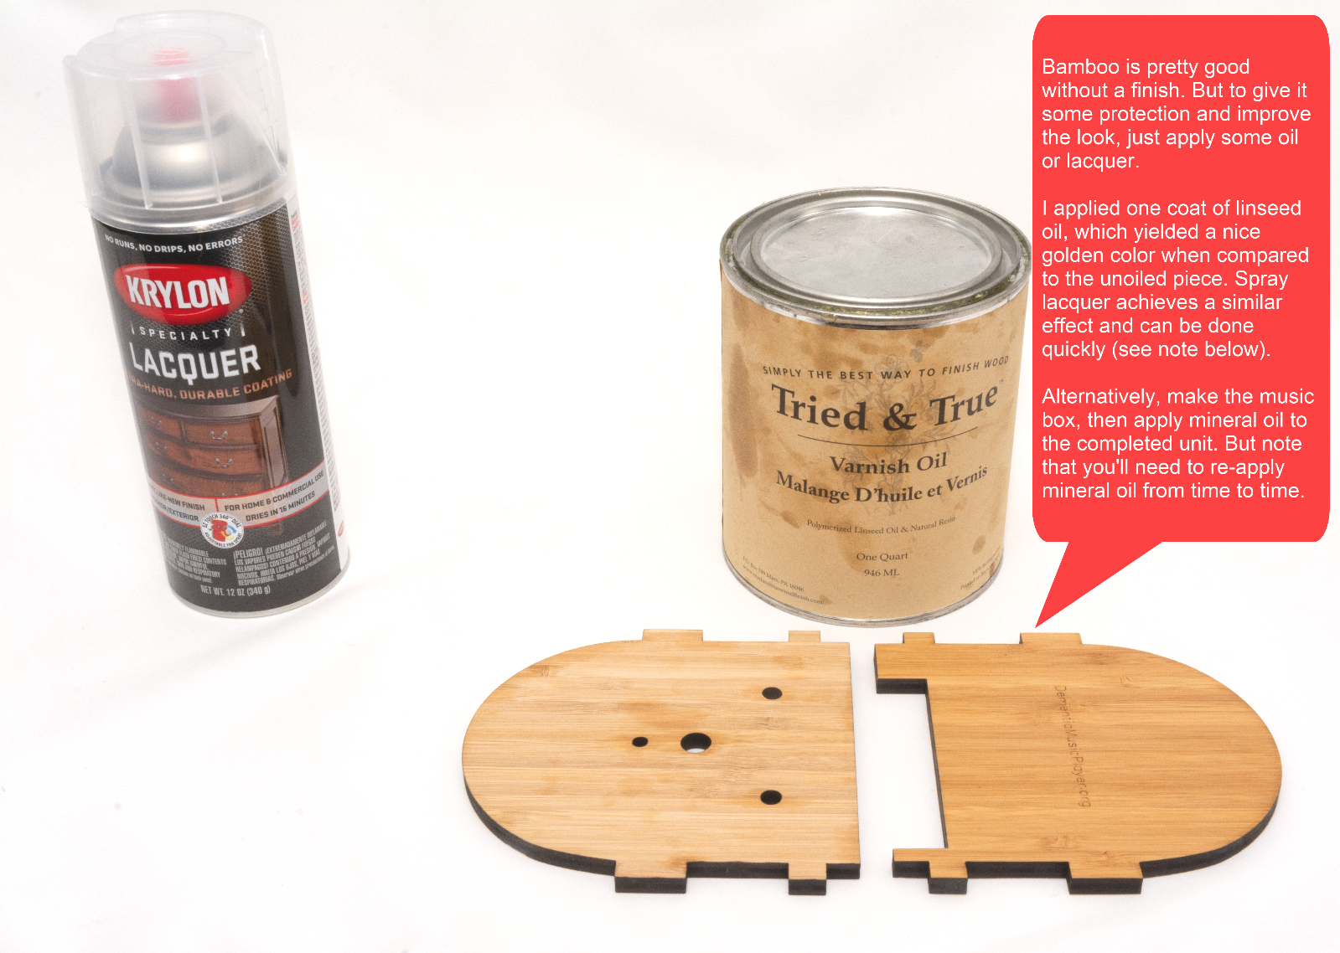

If you choose to use spray lacquer, see this [short video from Woodworking for Mere Mortals](https://www.youtube.com/watch?v=CyVPkqrNph0). The method shown is much faster than the instructions on the spray bottle. It takes about 15 minutes of work spread across two hours.

# STEP 16: Add the Pi

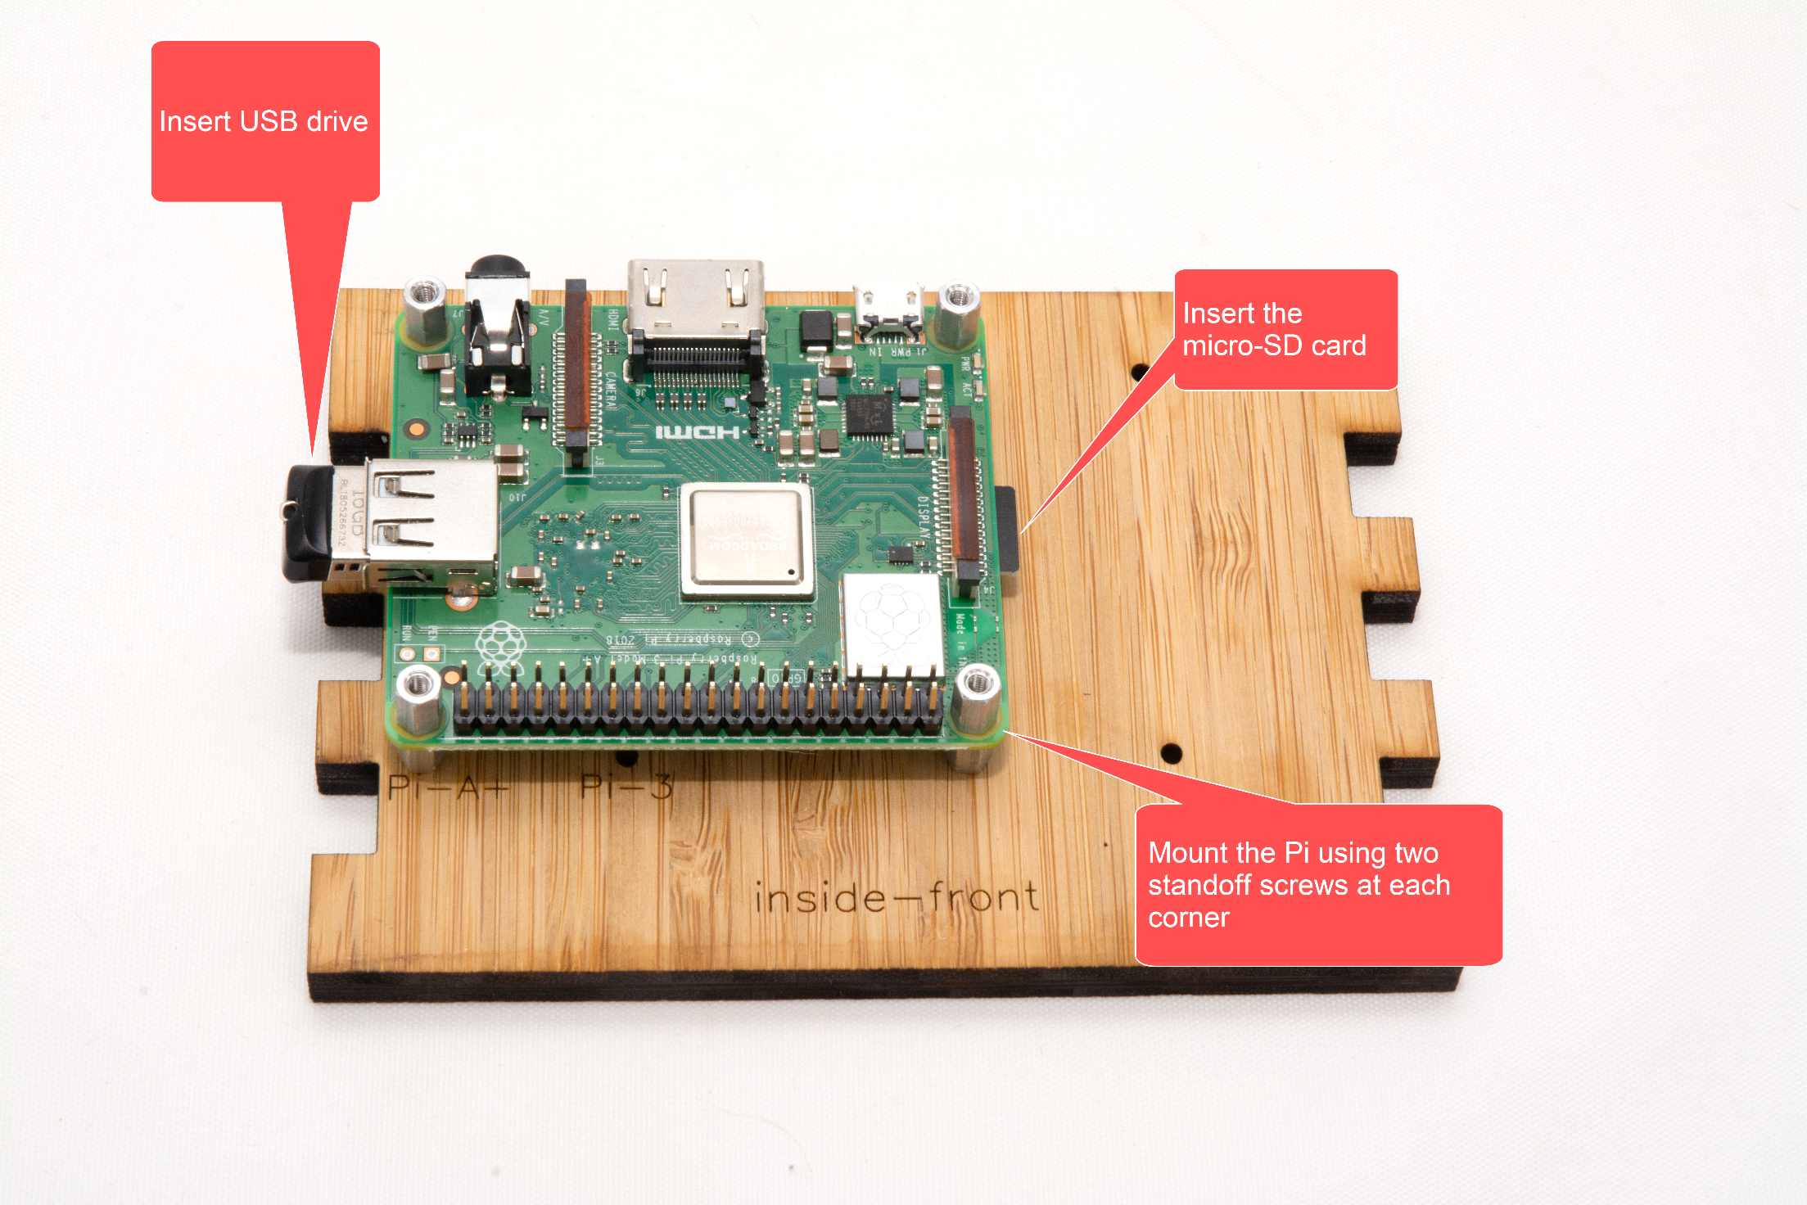

# STEP 17: Test it

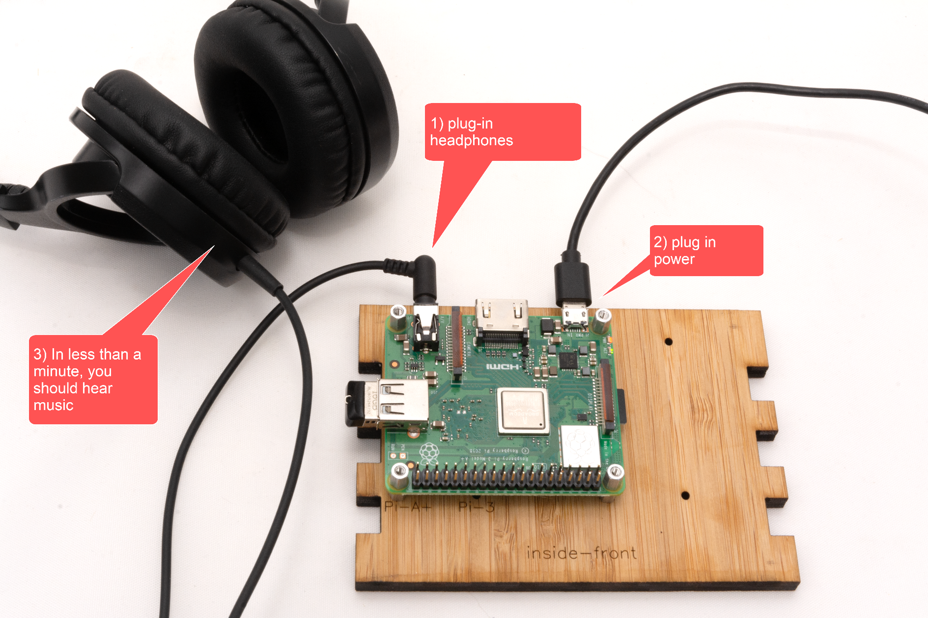

# STEP 18: Wire it

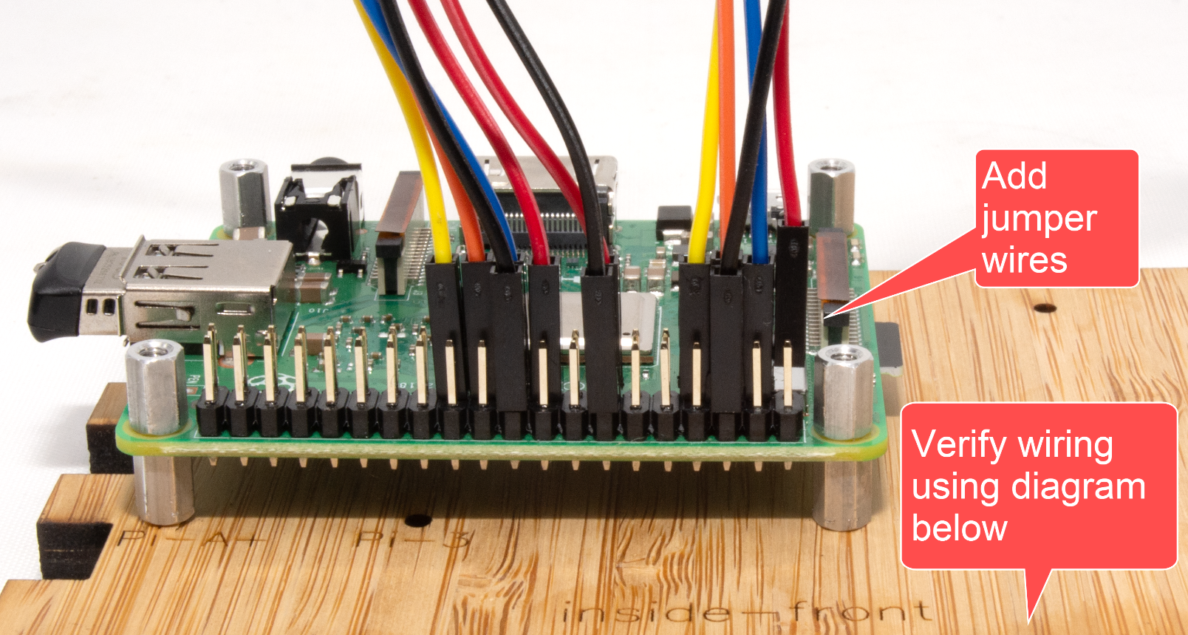

# STEP 19: Add front panel components

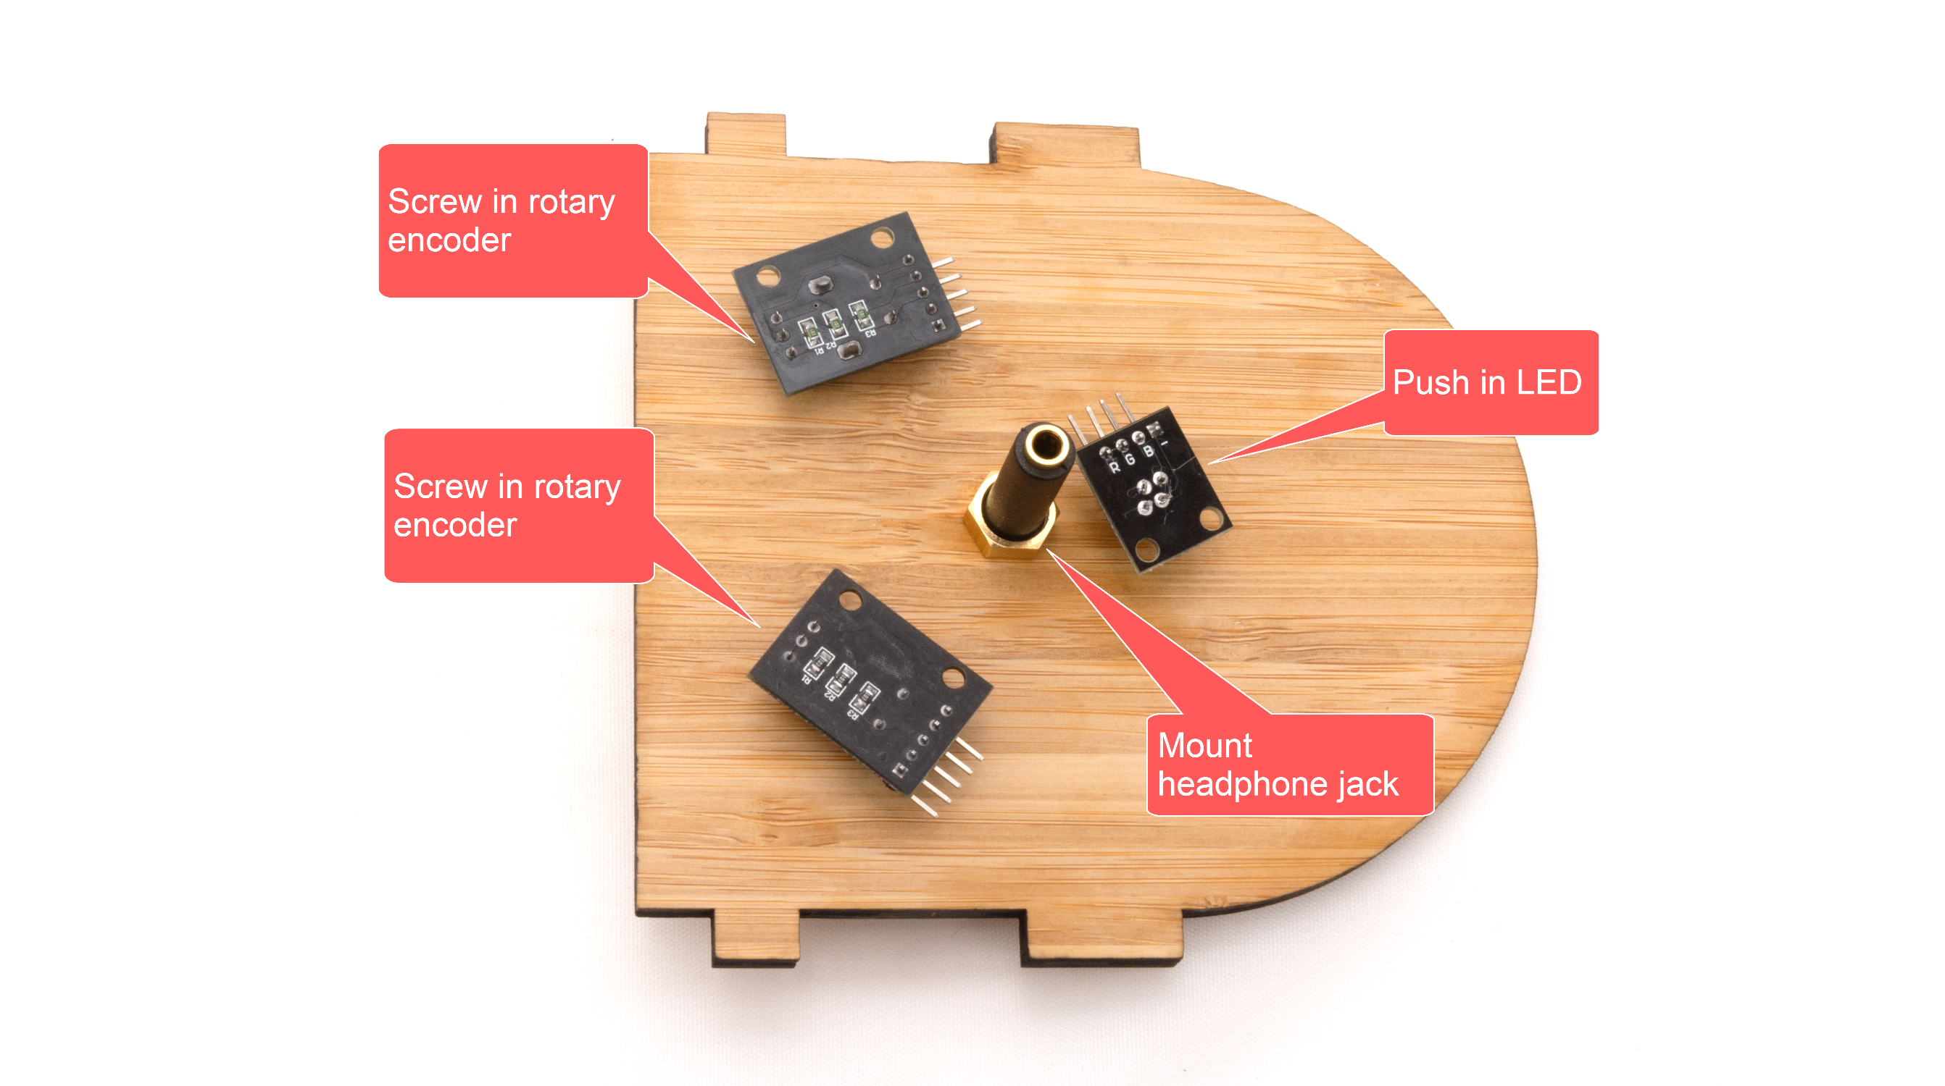

# STEP 20: Wire up front panel components

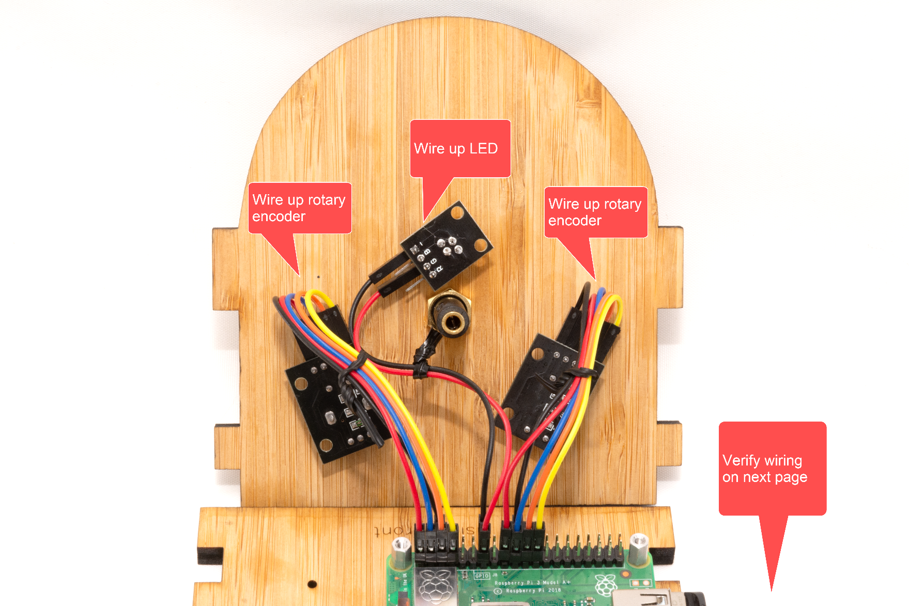

# STEP 21: Verify wiring



# STEP 22: Test it again

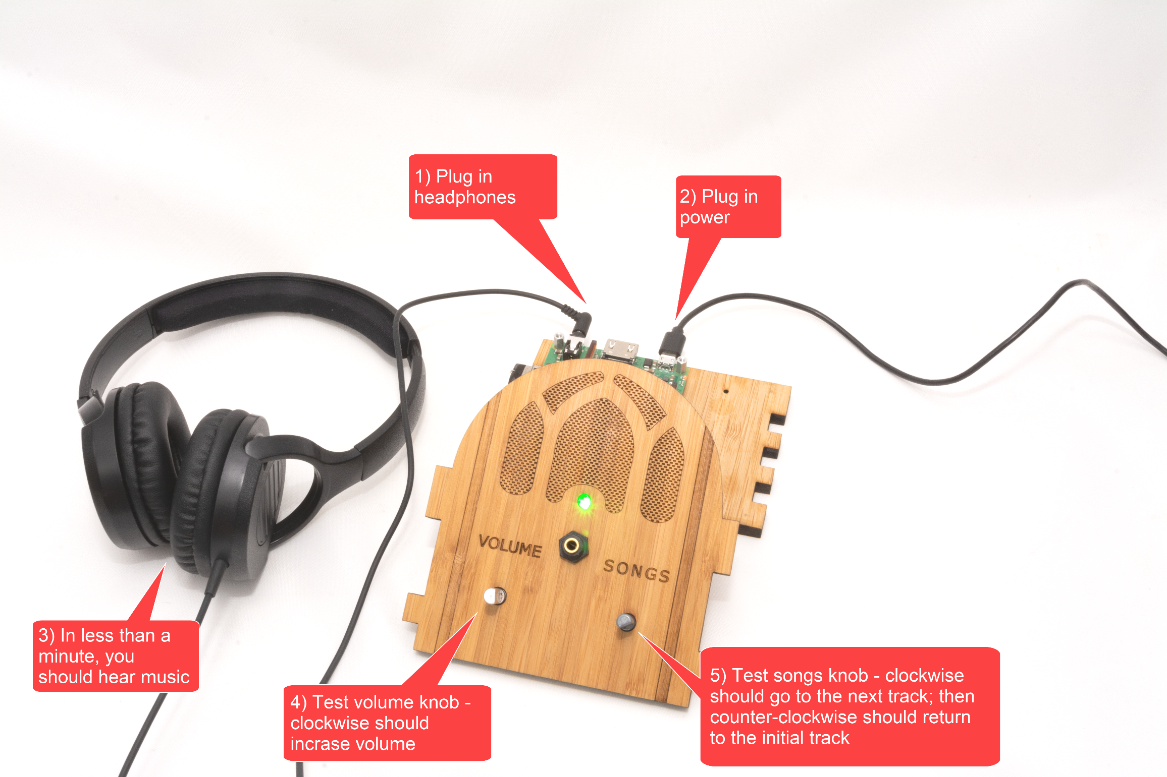

# STEP 23: Adjust the knob wiring (if necessary)

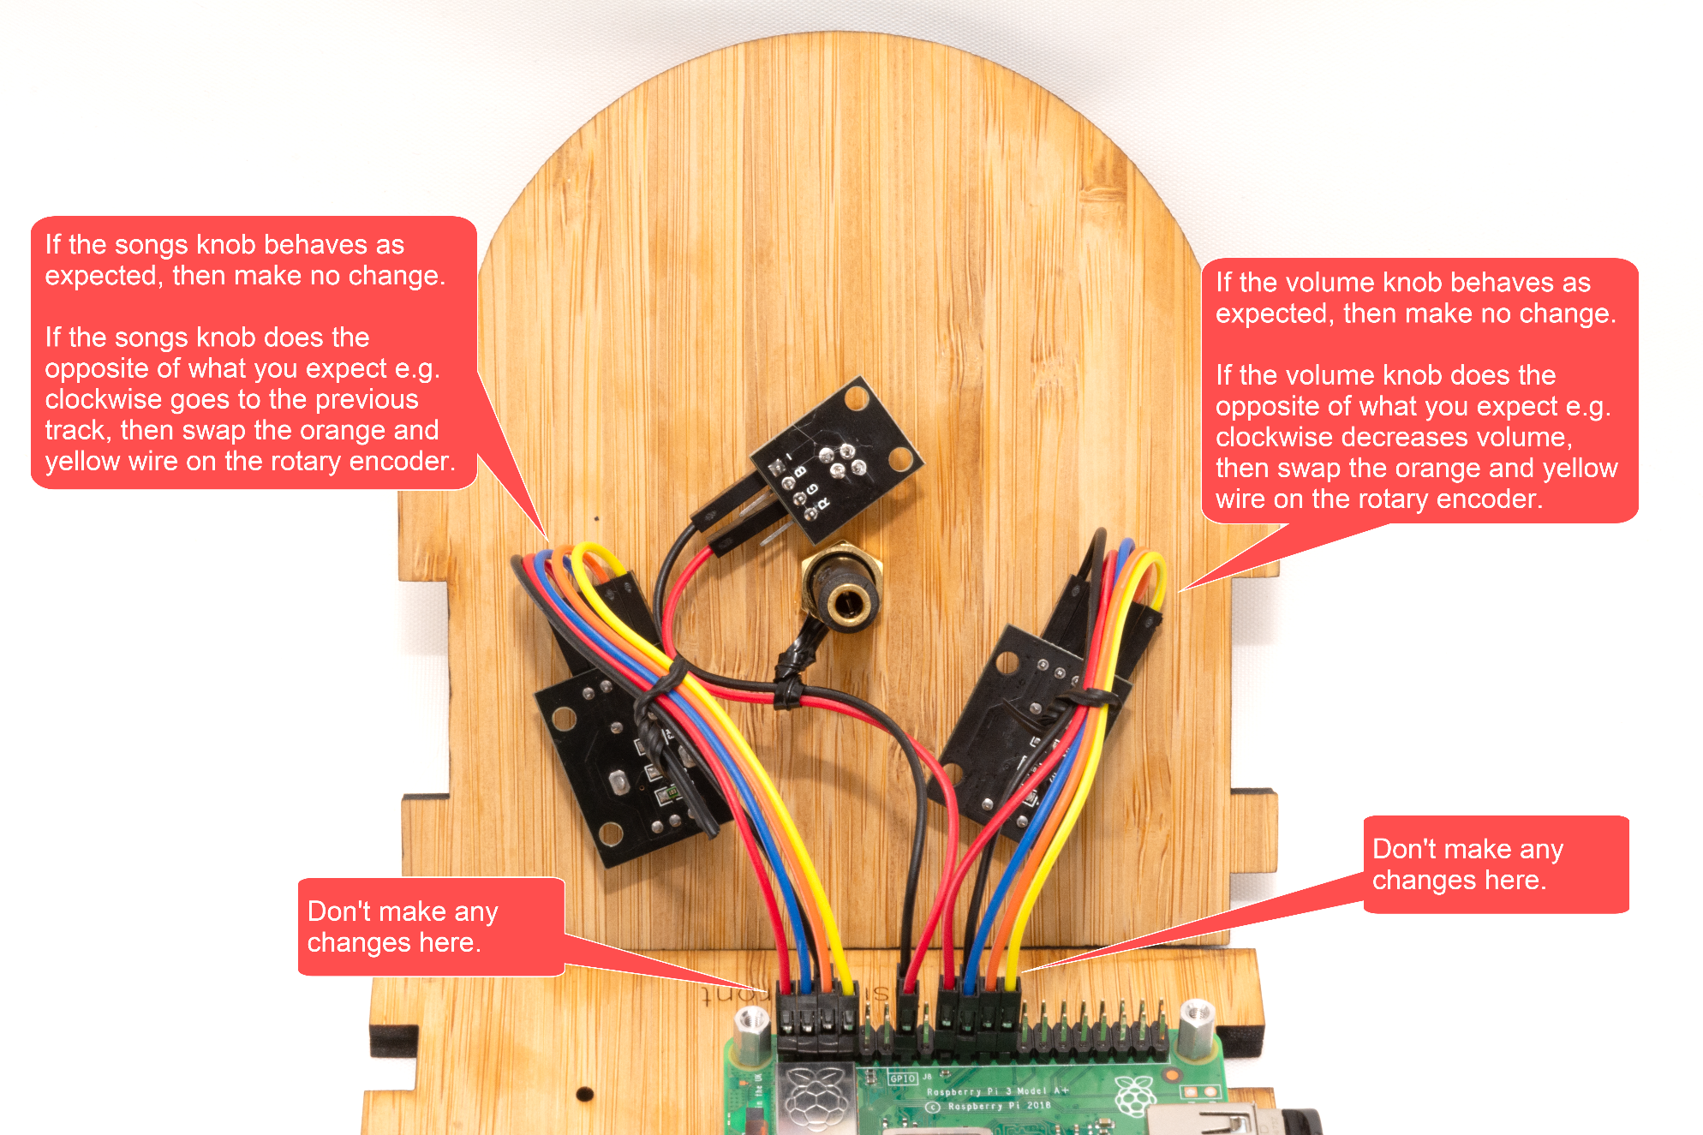

# STEP 24: Add glue

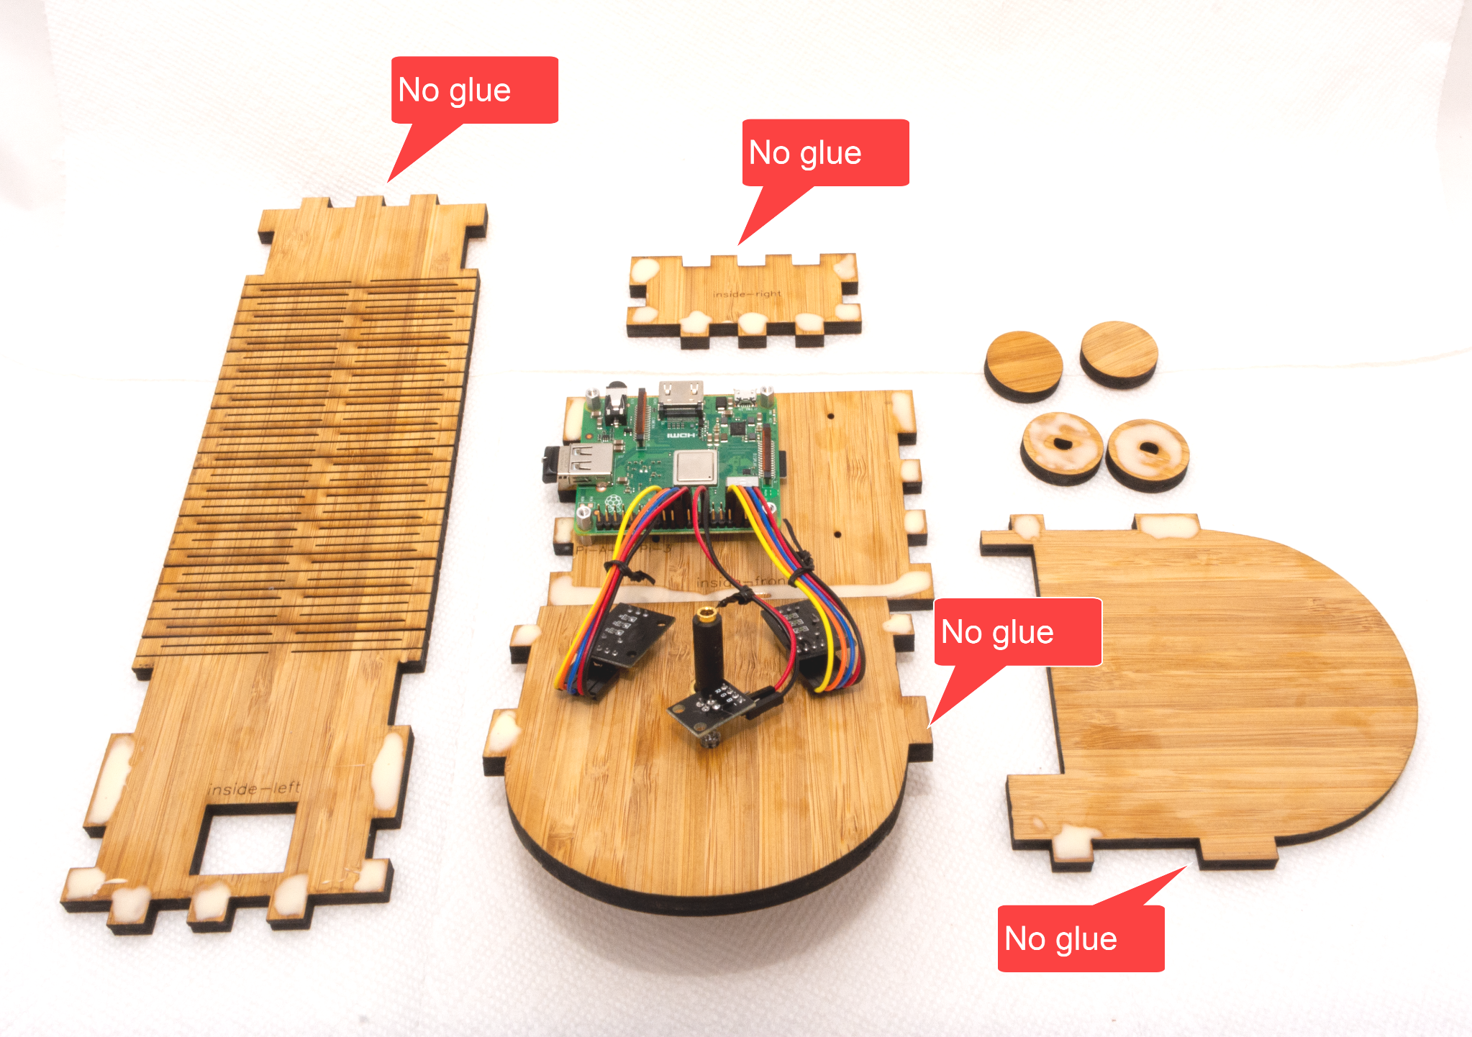

# STEP 25: Add audio cable

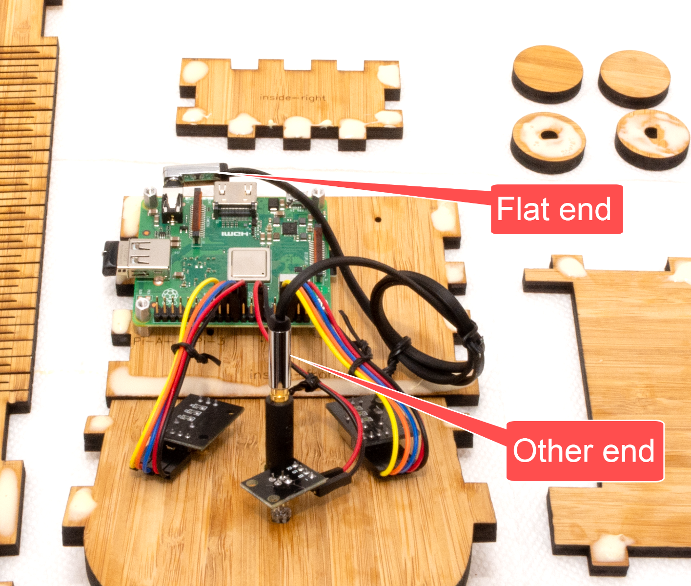

# STEP 26: Glue it

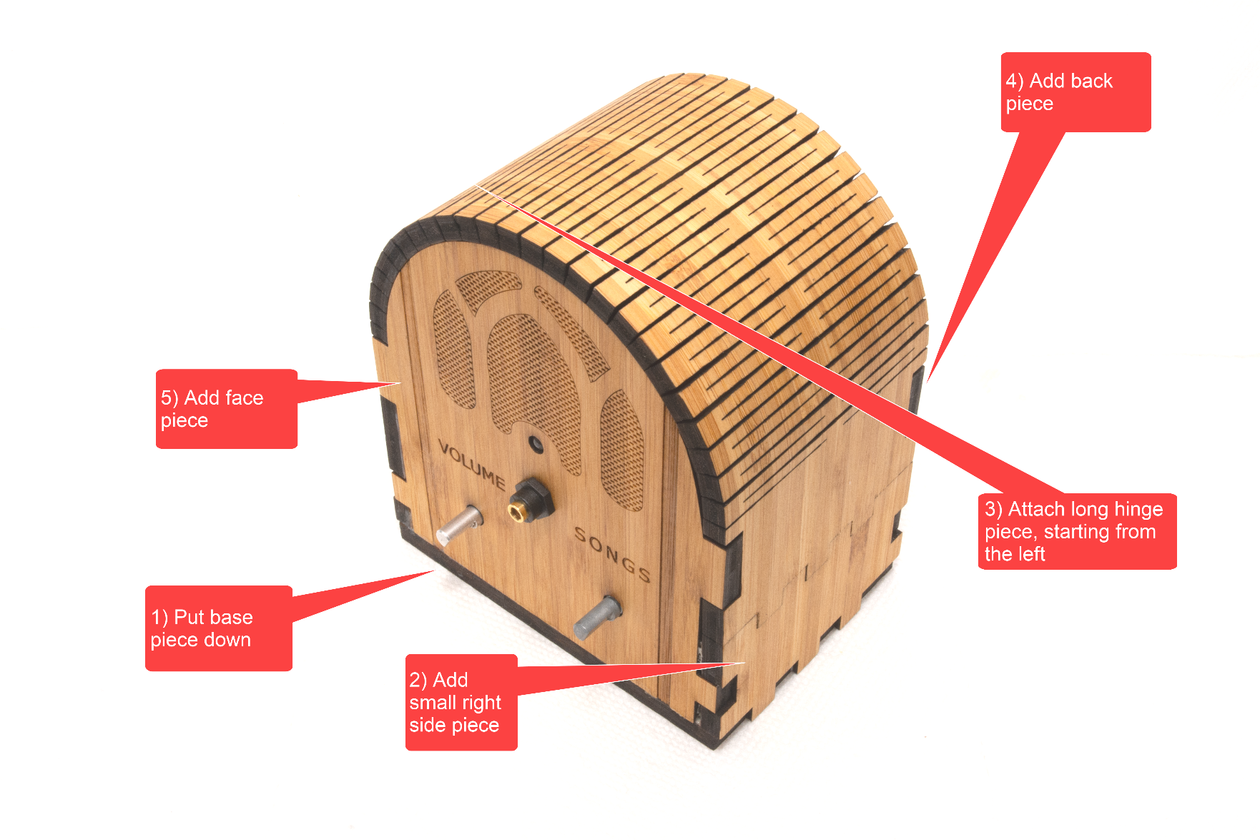

# STEP 27: Sand the clasp (if necessary)

If the clasp won’t close i.e. is too tight, then very lightly sand as per below. You can also do this after you have clamped & glued. So if your glue is starting to set as you read this, skip to the next step. Then return here after you take the clamp/tape off.

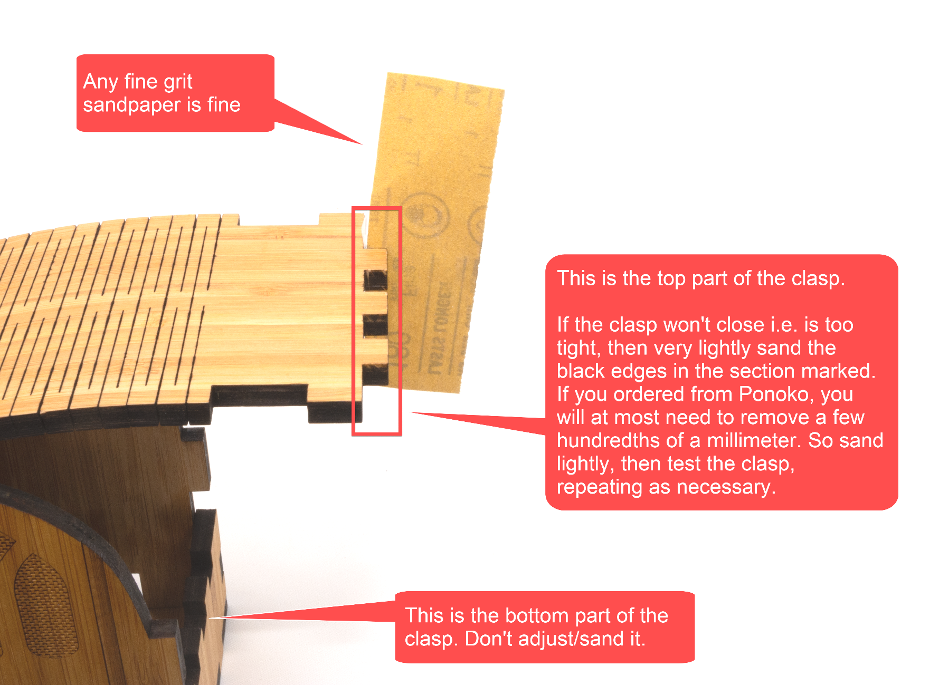

# STEP 28: Clamp it

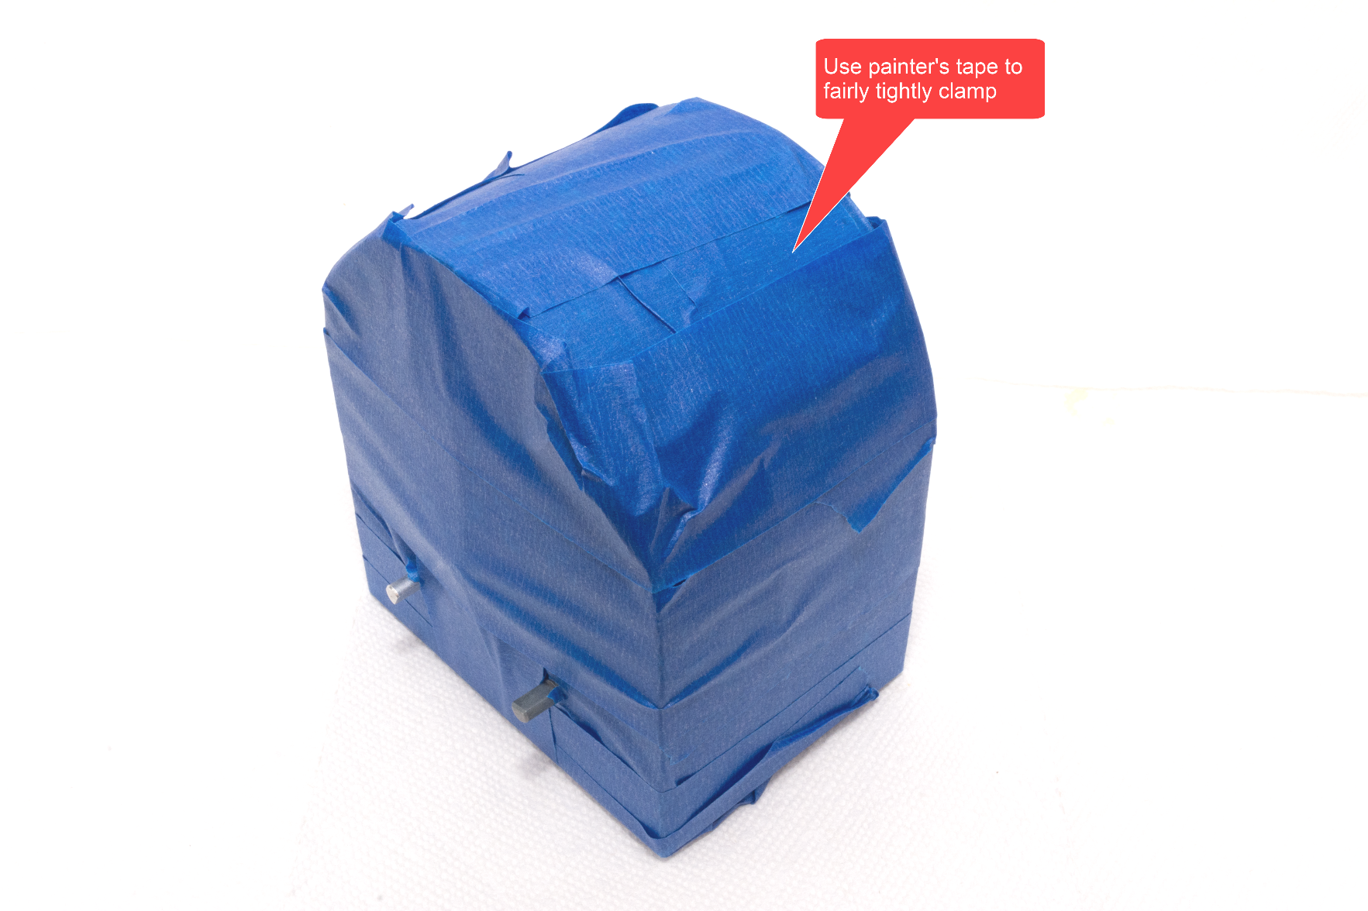

# STEP 29: Glue the knobs

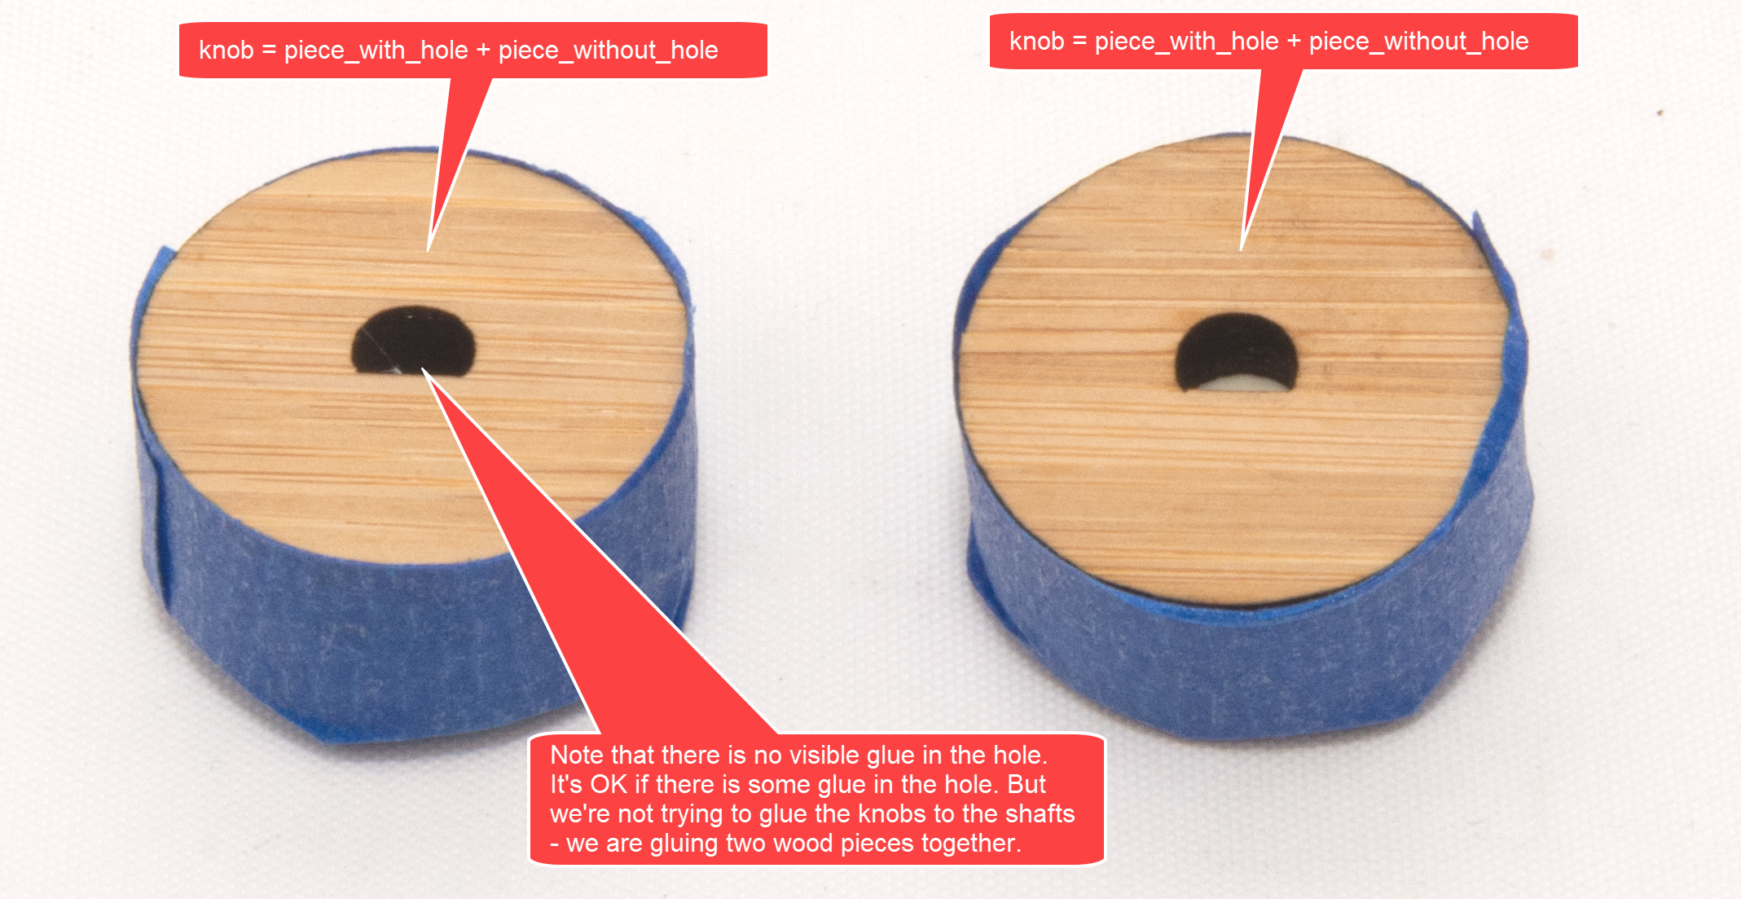

# STEP 30: Place knobs on shafts

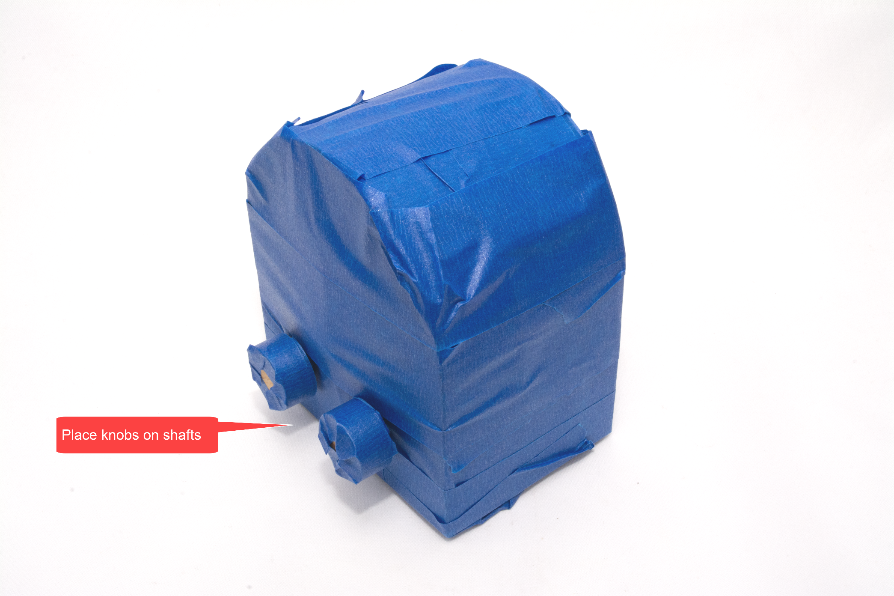

# STEP 31: Let the glue dry

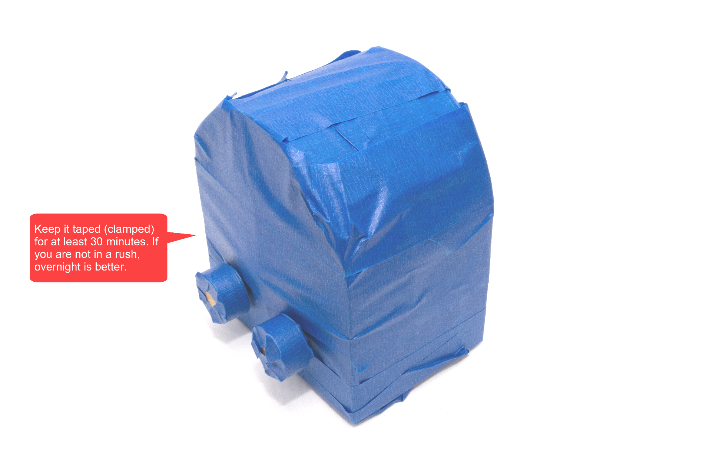

# STEP 32: Remove the tape

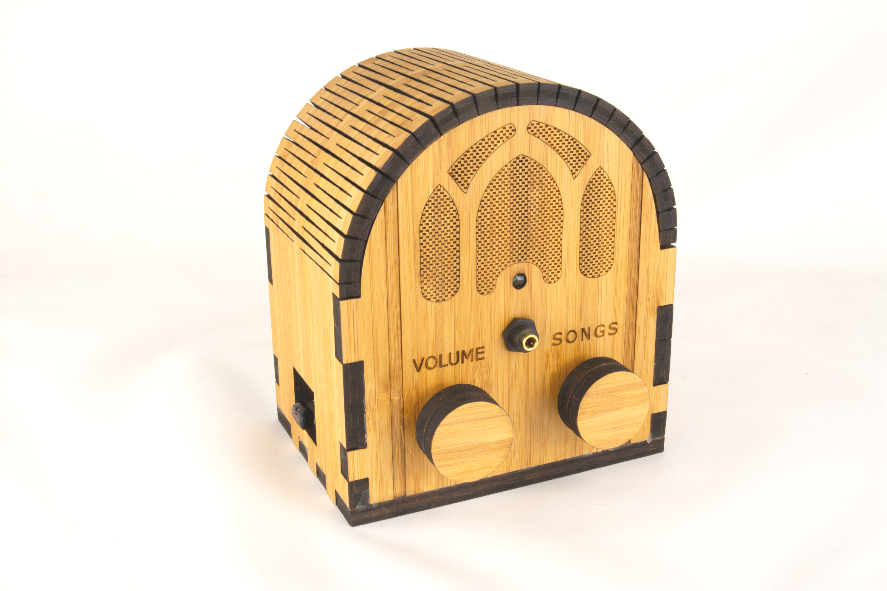

# STEP 33: Add glue to the clasp (if necessary)

If the clasp does not latch security i.e. is a bit loose, then very slightly increase the size of the tabs by applying a thin layer of glue and allowing it to dry before re-latching. If you ordered from Ponoko, it’s unlikely that you will have to do this. But if you do, then use a very thin layer of glue and perhaps only on the top of the latch. That is, if the Ponoko sizing is off, it’s only going to be off by a fraction of a millimeter.

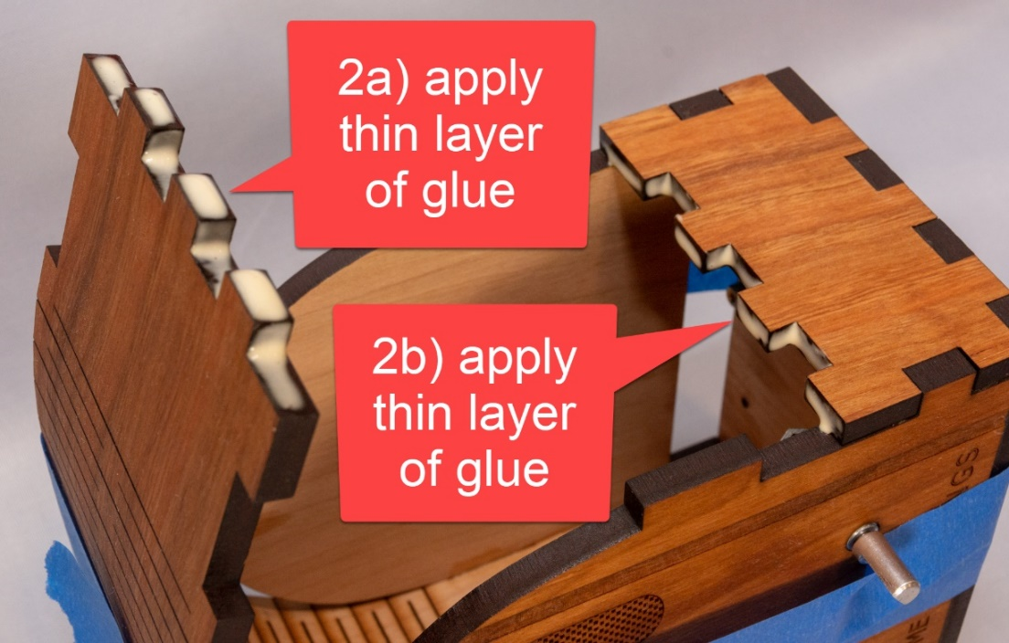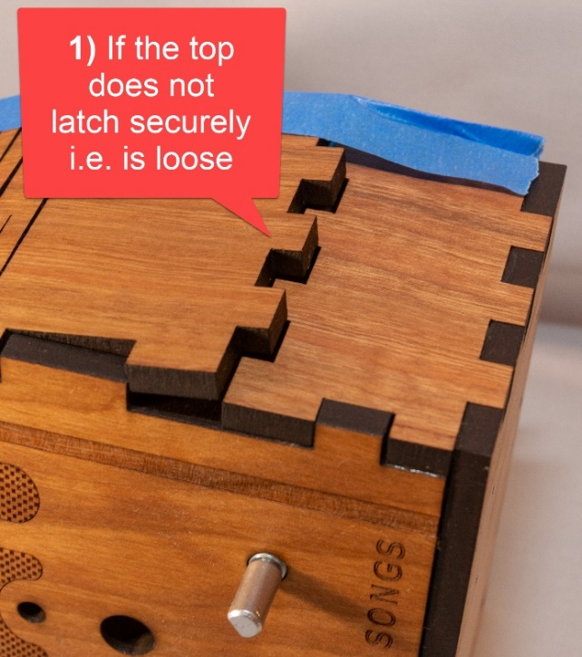



# STEP 34: Adjust the knobs (if necessary)

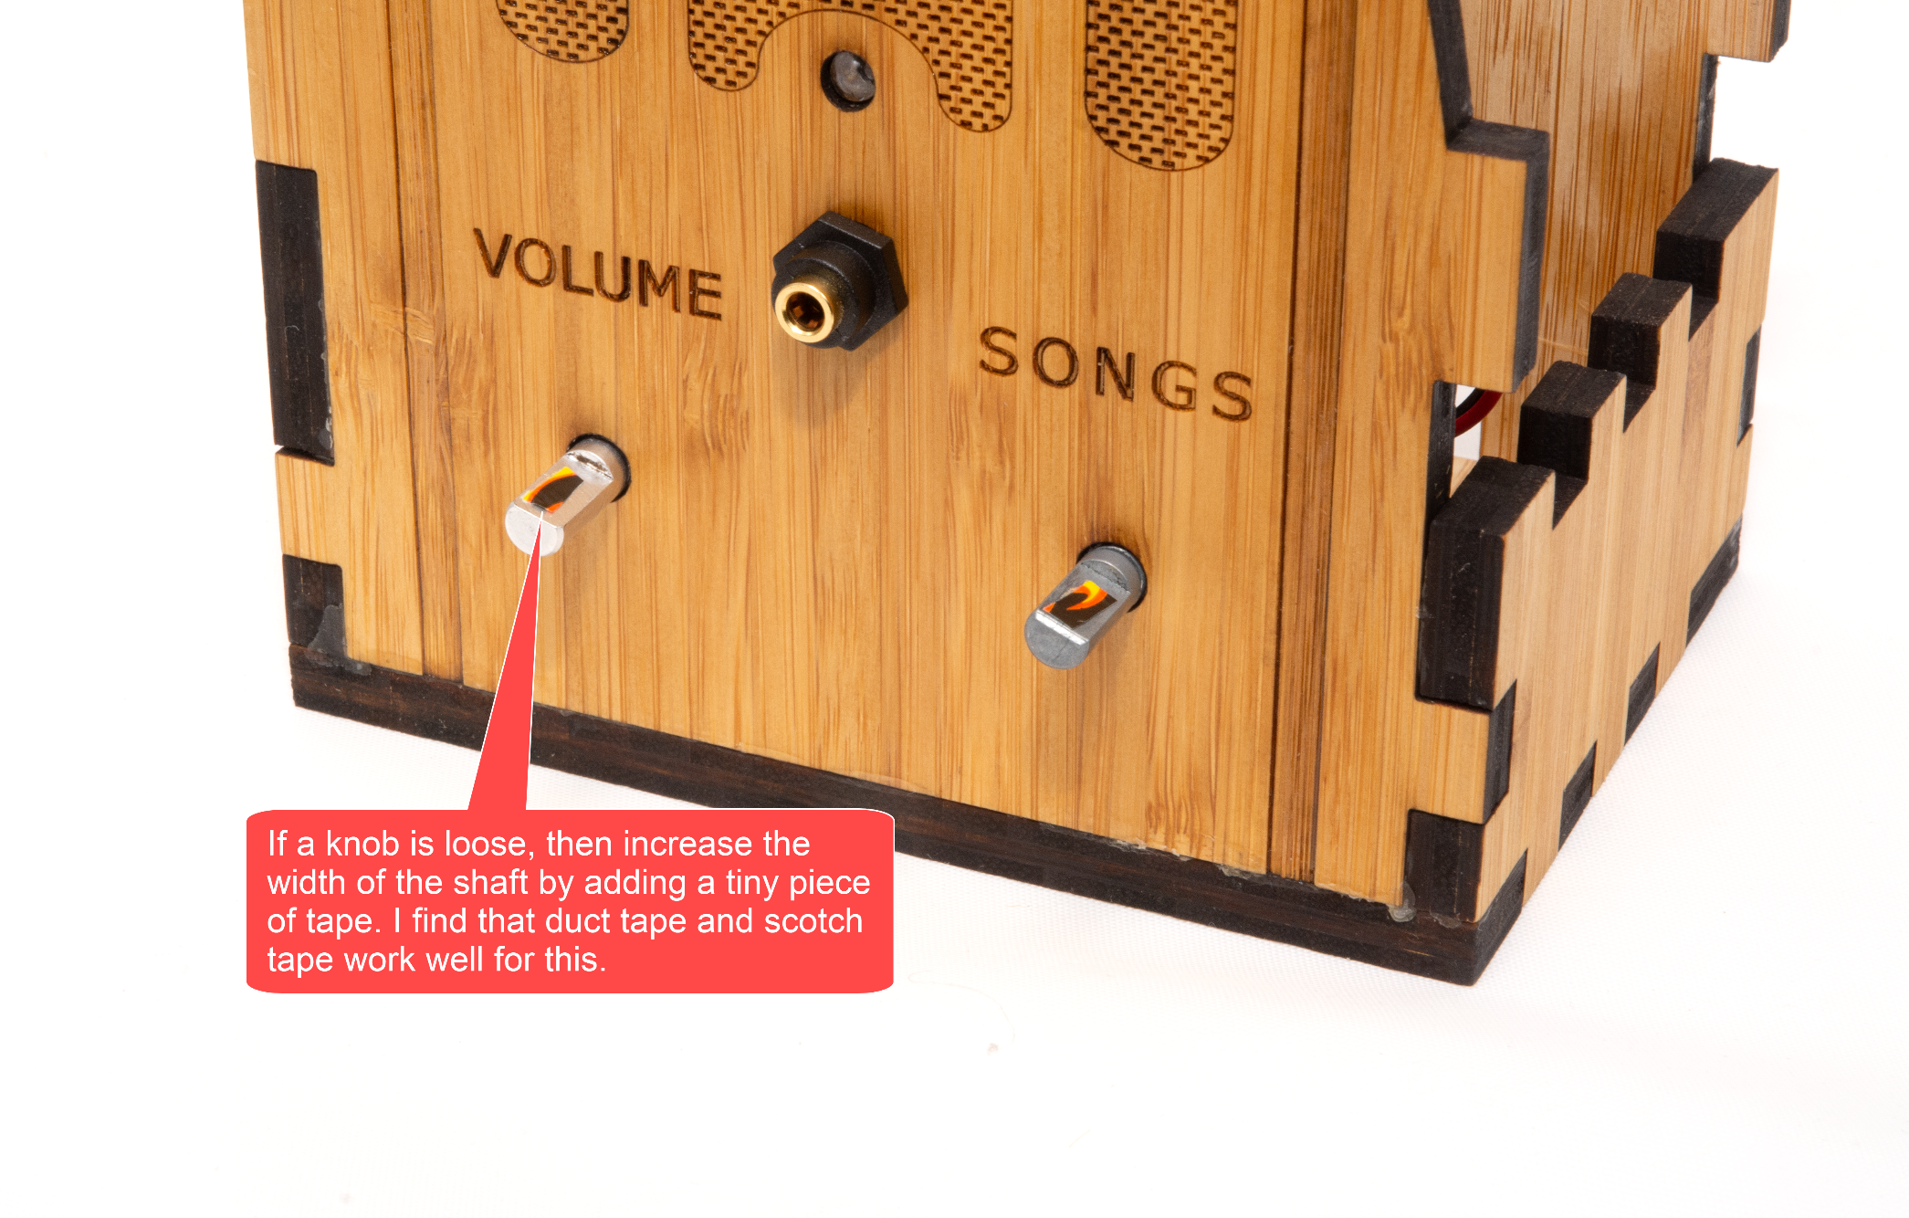

# STEP 35: Tape instructions

Print this page and tape the instructions in the box below to the bottom of your new Dementia Friendly Music Player:

|  |
| --- |
| **To create personalized music**  **Organize the music on your computer**  One folder per album. Use MP3 files, must have .mp3 file extension. Or iTunes files (.m4a). Or FLAC files (.flac). Optionally, use folder names prefixes to specify the play order e.g. A_, B_  **Copy the music to the USB thumb drive**   1. https://images-na.ssl-images-amazon.com/images/I/71cTRglrgcL._SL1500_.jpgUnplug the Dementia Friendly Music Player. 2. Remove the USB thumb drive and place in your computer. 3. Copy music files from your computer to the USB thumb drive. 4. Put the USB thumb drive back in. 5. Plug in your Dementia Friendly Music Player. |

# STEP 36: Done!

Congratulations! You should have a fully functional Dementia Friendly Music Player.

# Appendix 1: Building 10+ units at a time

Notes & assumptions:

* You want to build 10 or more units at a time
* You are planning this far enough in advance (8 weeks or more) that you can order some of the parts directly from China
* Two ways to make the case – laser cut it yourself or order with a quantity discount from Ponoko
* If Ponoko
  + The cost is ~$35
  + I recommend switching to 3.5mm cherry veneer wood:
    - It is significantly less expensive
    - It’s thinner so it’s a little harder to work with and a little less durable, but I think it’s fine for the 10+ purpose
    - It is pre-finished, which is a nice time saver
    - It will look like this:  
      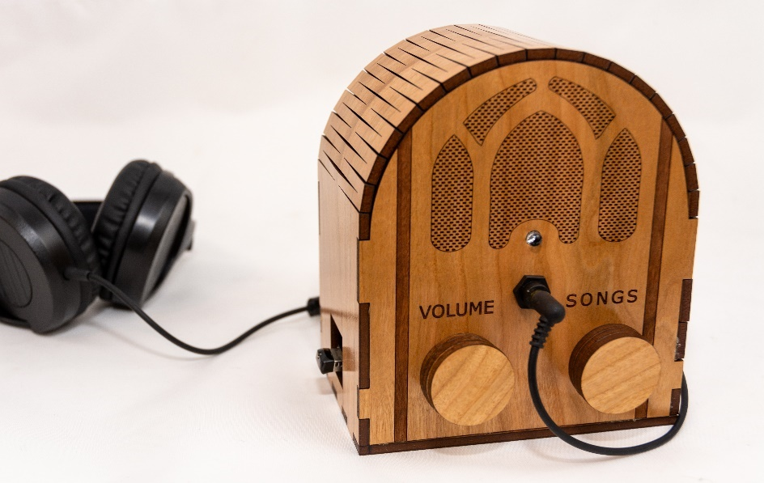
    - Be sure to use the matching laser cutting 3.5mm file from [github](https://github.com/rosswesleyporter/dqmusicbox/tree/master/case/standard_model)
    - You’ll need the rubber feet (see below) as the 6mm shaft of the standoffs will protrude slightly from the bottom of the case
* If you are planning to laser cut the case yourself, or in conjunction with a maker space, I suggest using 5.2mm cherry MDF wood
  + Looks great, is commonly available, laser cuts well
  + Ideally apply some wood finish (see above)
  + At my supplier, a 4’x8’ sheet is $55, and you can make as many as 12 cases from it
  + For the cost estimate below, I’m assuming 15 minutes of laser time at $1 per minute
  + For laser cutting, be sure to use the matching 5.2mm file from [github](https://github.com/rosswesleyporter/dqmusicbox/tree/master/case/standard_model)

|  |  |  |  |  |  |  |
| --- | --- | --- | --- | --- | --- | --- |
| # units to make | 10 |  |  |  |  |  |
|  |  |  |  |  |  |  |
| **Item** | **Supplier** | **Quan** | **Each** | **Total** | **Per unit** | **Notes** |
| Wood case | Maker space | 10 | $22.00 | $220.00 | $22.00 | Or order from Ponoko for ~$35 |
| [Raspberry Pi 1 A+ single board computer](http://www.newark.com/raspberry-pi/raspbrry-moda-512m/silicon-manufacturer-broadcom/dp/81Y5333) | Newark | 10 | $20.00 | $200.00 | $20.00 |  |
| [Power supply](https://www.newark.com/pro-elec/28-19339/adaptor-ac-dc-5-1v-2-5a/dp/51AC7144) | Newark | 10 | $4.99 | $49.90 | $4.99 |  |
| [Panel mount 3.5mm headphone jack](http://www.newark.com/mcm/27-5937/3-5mm-inline-stereo-mount-female/dp/40T6284) | Newark | 10 | $2.42 | $24.20 | $2.42 |  |
| [Female-female jumper wires](https://www.aliexpress.com/item/32800215149.html?spm=a2g0s.9042311.0.0.6b164c4d50jzDO) | Ali Express | 10 | $0.60 | $6.00 | $0.60 |  |
| [M2.5 6mm thread + 6mm standoff screws (100 pieces)](https://www.aliexpress.com/item/32789600225.html?spm=a2g0s.9042311.0.0.27424c4dxaP132) | Ali Express | 1 | $1.98 | $1.98 | $0.20 |  |
| [Audio cable](https://www.aliexpress.com/item/32828101917.html?spm=a2g0s.9042311.0.0.6b164c4d50jzDO) | Ali Express | 10 | $2.79 | $27.90 | $2.79 |  |
| [KY-016 indicator LED (10 pieces)](https://www.aliexpress.com/item/32955003054.html?spm=a2g0s.9042311.0.0.6b164c4d50jzDO) | Ali Express | 1 | $1.92 | $1.92 | $0.19 |  |
| [KY-040 rotary encoders (knobs)](https://www.aliexpress.com/item/599712551.html?spm=a2g0o.productlist.0.0.e62e585aMTYzjg&algo_pvid=f1759f37-1668-4260-a1ec-19fa8f3121f1&algo_expid=f1759f37-1668-4260-a1ec-19fa8f3121f1-3&btsid=0ab6f82215868356579722627e4fa1&ws_ab_test=searchweb0_0,searchweb201602_,searchweb201603_) | Ali Express | 20 | $0.72 | $14.40 | $1.44 |  |
| [16GB micro SD card](https://www.amazon.com/gp/product/B06XWN9Q99/ref=ppx_yo_dt_b_asin_title_o05_s00?ie=UTF8&psc=1) | Amazon | 10 | $7.49 | $74.90 | $7.49 |  |
| [USB thumb drive](https://www.amazon.com/gp/product/B077Y149DL/ref=ppx_yo_dt_b_search_asin_title?ie=UTF8&psc=1) | Amazon | 10 | $7.19 | $71.90 | $7.19 |  |
| [Sticky back rubber feet (100 pieces)](https://www.aliexpress.com/item/4000157727846.html?spm=a2g0o.productlist.0.0.844d376chGZHYJ&algo_pvid=f5f5fcdc-bb29-46e8-acd9-2cf392ad2bfa&algo_expid=f5f5fcdc-bb29-46e8-acd9-2cf392ad2bfa-3&btsid=0ab6d69515849159949164166e32c7&ws_ab_test=searchweb0_0,searchweb201602_,searchweb201603_) | Ali Express | 1 | $1.09 | $1.09 | $0.11 | Only needed for wood < 6mm thick |
|  |  |  |  |  | **$69.42** | + tax + shipping |